Recap – Big Bang Theory
More than 14 billion years ago, there was nothing: no matter, no energy, no space.
Scientists believe the universe began in a very hot, dense state that expanded rapidly and cooled to eventually condense into galaxies. Called a singularity.
Evidence to support their theory.
- Universe expansion and Red Shift: Light travels to Earth from other galaxies. As the light from that galaxy gets closer to Earth (emitted light), the distance between Earth and the galaxy increases, which causes the wavelength of that light (perceived/observed) to get longer (redshift). Similar to sound waves: As an ambulance gets closer, the siren seems to increase in sound and decreases as it moves away from you. Redshifted = away. Blueshifted = toward.
  - Frequency – number of waves that pass a given point each second.
  - Wavelength – the distance between successive crests of a wave (sound or electromagnetic)
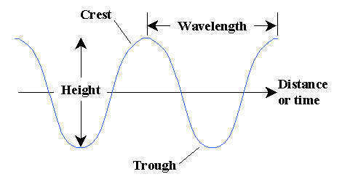

- Cosmic Background Radiation: If the universe began in a highly compressed state, as the Big Bang theory suggests, it would have been very hot, and the high temperatures would have filled it with radiation (energy). If radiation filled the universe back then, that same radiation should still fill the universe. In 1965, scientists discovered a persistent background noise from space caused by weak radiation that was radiating from all directions and was consistent with the temperature thought to happen during the Big Bang. Scientists have confirmed that it matches the properties of the predicted leftover radiation.
- The abundance of the “light elements” hydrogen and helium found in the observable universe. Matter in the form of free neutrons and protons were very hot and dense. They existed as a plasma and did not have electrons. As the universe expanded, the temperature fell and some of these nucleons were synthesized (combined) into the lighter elements. Hydrogen was the first element to form and along with Helium became the fuel for the stars.

