Cosmology
___________________________ The study of the universe, its nature, origin, and evolution.
The origin of the universe: Two theories
_________________________________________________The universe looks the _________ to all observers, and that it always looked that way.
____________________________________ The universe began in a very hot, dense state that expanded rapidly and cooled to eventually condense into galaxies. Called a _______________.
- The universe began as a point and has been _______________________ ever since.
- This implies that the universe had a ______________________. Not an “explosion”.
- About _____________________________________, a sphere of gas expanded outward sending __________________ and ______________________ in a giant cloud.
- Clumps of matter evolved into ________________________.
- ________________ ___________________ The fundamental force holding things together in the universe. (Law of Gravity)
- The evidence
  - The _________________ in the galaxy light spectrum (Doppler shift) show that galaxies are moving away from each other (like a firecracker right after the initial explosion.)
  - In 1965, scientists discovered a persistent background noise from space caused by weak radiation called ____________________________________________. This radiation was radiating from all directions and was consistent with the temperature thought to happen during the Big Bang.
  - The abundance of the “light elements” ______________ and _______________ found in the observable universe.
- In the Big Bang model, there is competition between the outward momentum of expansion of the universe and the inward force of gravity as the matter in the universe acts to slow the expansion. - Three possible outcomes depends on which of these two forces are stronger:
  - _________________ ______________________ - expansion won’t stop
  - _____________________________ - expansion stops and turns into contraction.
  - _________________________ - expansion will slow to a halt, but never contract.

____________________________ The first scientist to determine that there were several other galaxies, such as our Milky Way, in existence. Up until this discovery, scientists believed that our galaxy was the entire universe.

The Electromagnetic Spectrum
Diagram showing the wavelengths of energy divided into different categories.
The high-energy bands have very short wavelengths. As the energy level decreases, the wavelength increases.
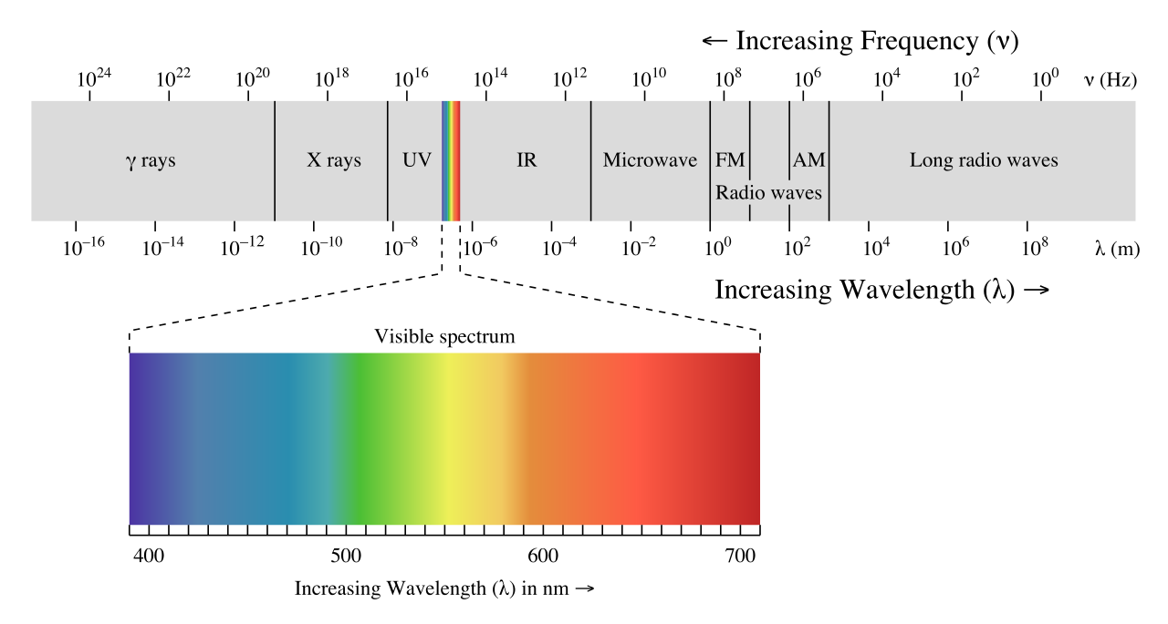
- Radio Waves – have the longest wavelength. These waves carry the news, ball games, and music you listen on the radio.
- Microwave – have shorter wavelengths than radio waves, which heat the food we eat. They are also used for radar images, like Doppler radar used in weather forecasts.
- Infrared waves – Two types: Long wavelengths can be detected as heat called thermal infrared. Example – your radiator or heater. Shorter wavelengths called near infrared waves are given off by the sun.
- Visible light waves – the only waves we can see (colors of the rainbow). Red is the longest and violet is the shortest. Combined they make white light.
- Ultraviolet waves – shorter than visible light waves – invisible to the human eye, but some insects can see them. Responsible for causing our sunburns.
- X-Rays – smaller wavelengths and therefore more energy than the ultraviolet waves. Powerful enough to pass easily through the skin allowing doctors to look at our bones.
- Gamma rays – smallest wavelength and most energy of the wavelengths. Generated by radioactive atoms and in nuclear explosions. They can kill living cells, but doctors can use them to kill diseased cells.
The Doppler Shift
- As an object moves away from you or moves toward you, there is a small change in the wavelengths of light that are given off.
- Blue shift – If the object is coming toward you, the waves are compressed, making the wavelengths shorter. This moves the bands of light to the blue (shorter) side of the visible light spectrum.
- Red shift – If the object is moving away from you, the waves are stretched out, making them longer. This moves the band of light seen toward the red (longer) side of the visible light range.

