Cosmology
Cosmology: The study of the universe, its nature, origin, and evolution.
The origin of the universe: Two theories
Steady State Theory: The universe looks the same to all observers, and that it always looked that way.
Big Bang Theory: Scientists believe the universe began in a very hot, dense state that expanded rapidly and cooled to eventually condense into galaxies. Called a singularity.
- The universe began as a point and has been expanding ever since.
- This implies that the universe had a beginning. Not an “explosion”.
- About 14 billion years ago, a sphere of gas expanded outward sending matter and energy in a giant cloud.
- Clumps of matter evolved into galaxies.
- Gravitational force: The fundamental force holding things together in the universe. (Law of Gravity)
The evidence to support the theory.
- Universe expansion and redshifts in the galaxy light spectrum (Doppler shift) show that galaxies are moving away from each other (like a firecracker right after the initial explosion.) Light travels to Earth from other galaxies. As the light from that galaxy gets closer to Earth (emitted light), the distance between Earth and the galaxy increases, which causes the wavelength of that light (perceived/observed) to get longer (redshift). Similar to sound waves: As an ambulance gets closer, the siren seems to increase in sound and decreases as it moves away from you. Redshifted = away. Blueshifted = toward.
Measured by examining the absorption or emission lines in the objects (galaxy) spectrum. These line are unique for each element and always have the same spacing. When an object in space moves toward or away from us, the lines can be found at different wavelengths than where they would be if the object were not moving.

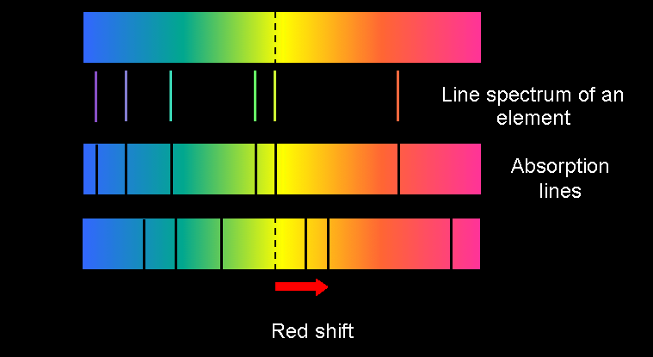
The Doppler Shift/Effect
- Electromagnetic radiation – energy in the form of waves. Planets, stars, and galaxies emit electromagnetic radiation.
- Blue shift – If the object is coming toward you, the waves are compressed, making the wavelengths shorter. This moves the bands of light to the blue (shorter) side of the visible light spectrum.
- Red shift – If the object is moving away from you, the waves are stretched out, making them longer. This moves the band of light seen toward the red (longer) side of the visible light range.
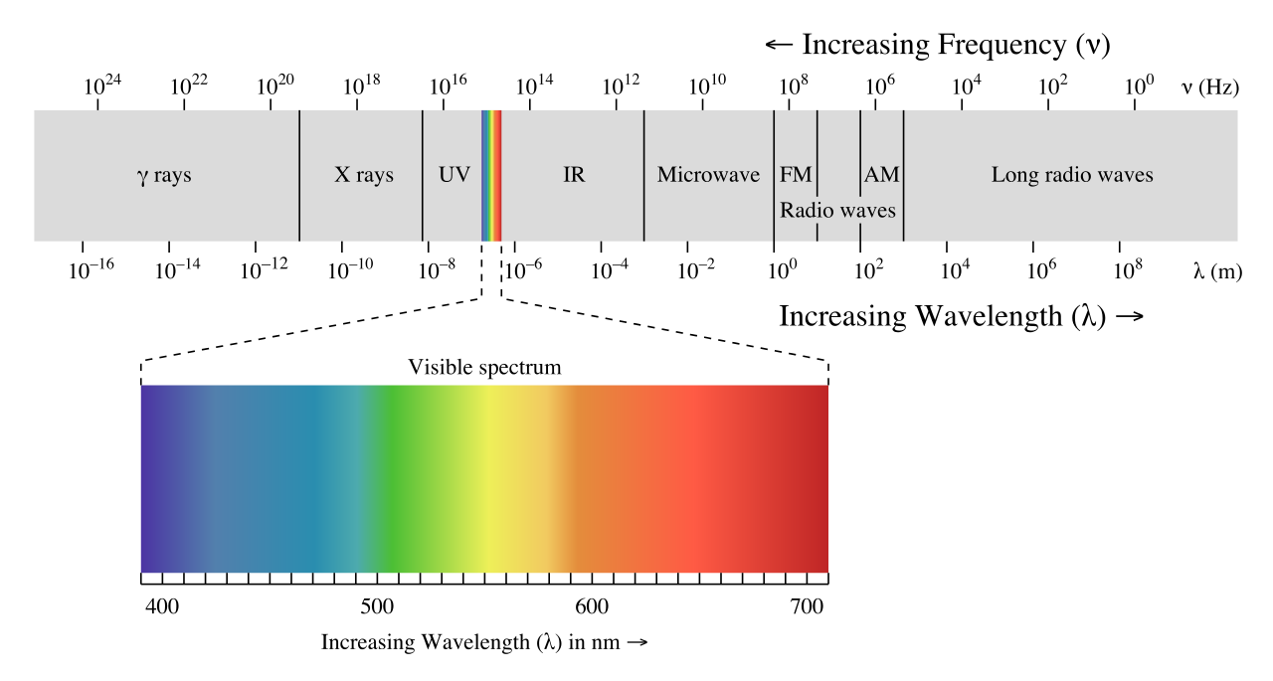
- In 1965, scientists discovered a persistent background noise from space caused by weak radiation called cosmic background radiation. This radiation was radiating from all directions and was consistent with the temperature thought to happen during the Big Bang. If the universe began in a highly compressed state, as the Big Bang theory suggests, it would have been very hot, and the high temperatures would have filled it with radiation (energy). If radiation filled the universe back then, that same radiation should still fill the universe. Scientists have confirmed that it matches the properties of the predicted leftover radiation.

- The abundance of the “light elements” hydrogen and helium found in the observable universe. Matter in the form of free neutrons and protons were very hot and dense. They existed as a plasma and did not have electrons. As the universe expanded, the temperature fell and some of these nucleons were synthesized (combined) into the lighter elements. Hydrogen was the first element to form and along with Helium became the fuel for the stars.

Edwin Hubble The first scientist to determine that there were several other galaxies, such as our Milky Way, in existence. Up until this discovery, scientists believed that our galaxy was the entire universe.

