LESSON PLAN FORMAT

School Site: Middle School Content/Endorsement Area: Special Education/English

Grade Level: 6 – 8 Daily Topic: Text Structures: Problem/Solution

Unit Topic: Multicultural Literature: An Exploration of Diversity Amongst Cultural Groups

Lesson # _ 3__ (3 of 5)

* **Pre-Planning**: Academic Foundations/Standards or Benchmarks**:** 
  + Virginia Standards of Learning Objectives
    - Reading
      * 6.5, 8.6 The student will read and demonstrate comprehension of a variety of informational selections.
        + Identify questions to be answered.
        + Make, confirm, or revise predictions.
        + Use context to determine meanings of unfamiliar words and technical vocabulary.
        + Draw conclusions and make inferences based on explicit and implied information.
        + Organize the main idea and details to form a summary.
      * 7.5 The student will read and demonstrate comprehension of a variety of fiction, narrative nonfiction, and poetry.
        + Describe setting, character development, plot structure, theme, and conflict.
        + Draw conclusions based on explicit and implied information.
        + Make inferences based on explicit and implied information.
        + Summarize text.
* **Instructional Setting**: This lesson was developed for a self-contained class containing sixteen students in the special education program. The classes are 45 minutes long. The students’ desks are arranged in a manner to allow clear vision of the board and the screen for when using the LCD projector and document camera. There are three long cafeteria tables along the back of the room students can use for projects and activities requiring small groups as well as more space. There are seven Ipads and one desktop computer available for student use.
* **Goal of the Lesson**: The goal of this lesson is for students to learn how to complete a problem solution outline based on the main character in the story in order to focus on the “problem, attempted solutions, the result or outcomes associated with the attempted solutions and the end result” (Vacca, Vacca, & Mraz, 2014, p. 204). The students will practice the activity in small groups in the classroom using the same story as the prior lesson, and then students will complete on individually as pertained to their independent novel study.
* **Behavioral Objectives**:

1. The Behavior Verb: Each student will complete the problem/solution outline in complete sentences.
   1. P.I.: Each student completed the problem/solution outline in complete sentences.
2. The Condition: While respectfully collaborating with others in the small groups, students will determine the problem and solutions.
   1. P.I.: Each student respectfully collaborated with others in their small groups.
3. The Criteria: Upon analyzing the story and the background information, each student will have developed responses for the character’s problem, attempted solutions, and final outcome.
   1. P. I.: Each student developed responses as required by the problem/solution outline.

* **Integration of other subject areas**: This lesson plan continues to parallel the social science content area through the lessons about the history of the atomic bomb, the relationship between the bombing of Hiroshima and a young Japanese girl, and the significance of an ancient Japanese legend and its impact all over world including the Tribute to the World Trade Center Visitor’s Center. Furthermore, this lesson introduces students to the reading strategy which they will independently use as part of their novel studies which also parallel the social studies content areas in all grade levels.
* **Differentiation Strategies**:
  + Culturally Responsive: Spanish cognates of pertinent vocabulary words will be available to the English Language Learner (ELL). Also, the English language learner will be provided with one-on-one assistance as needed to clarify, understand, and complete the activity.
  + Students will work in cooperative learning groups.
  + Students will be able to use Ipads in pairs or small groups to read the free PDF version of the Japanese story cards.
  + Students will be assessed individually as they may vary in their responses based on individual ability levels, individual grade levels, and within the limitations of the Individualized Education Plans (IEPs)
* **Safety considerations**:
  + Safety considerations include appropriate use of the technology equipment during the assignment, and safe use of scissors after the assignment.
* **Resources, Equipment and Materials**:
  + Copies of the attached background information which was teacher generated using Microsoft Word, but based on the original work written by Naomi Funahashi and Waka Takahashi Brown in collaboration with the Stanford Program on International and Cross-Cultural Education (SPICE) made possible by a grant from the United States-Japan Foundation.
  + Copies of the attached teacher generated Admit Slip
  + Copies of the attached teacher generated Problem/Solution Outline
  + Copies of the attached teacher generated Exit Slip
  + Technology:
    - LCD Projector
    - Document Camera
    - Ipad-Download Free PDF file:

Funahashi, N. (2011)*. Sadako’s paper cranes and lessons of peace.* Retrieved from <http://spice.stanford.edu/catalog/kamishibai_project/>*.*

* **Prerequisites**: Students will have already completed the QAR reading strategy as outlined in the previous lesson plan.
* **Implementation**: (1 Day – 45 minutes)
* **Motivator**:
  + **Before Reading Activity** – Admit Slip (10 minutes)
    - Students will complete an admit slip to convey any questions, concerns, or misunderstandings about the previous QAR activity which accompanied *Sadako’s Paper Cranes and Lessons of Peace* (Vacca, Vacca, & Mraz, 2014, p. 290).
* **Procedures**:
  + **During Reading Activity**: Problem/Solution Outline (30 minutes)
    - Students and teacher will preview and discuss the structure of the problem/solution outline. Students have been exposed to a problem/solution outline in the past; therefore, they should not need additional instruction in the reading skill.
    - Students will work together in cooperative learning groups to determine the primary problem, evaluate attempted solutions made by the character as well as the character’s friends and family.
    - Students will discuss and record the final outcome and make a relationship between the problem, the attempted solutions, and the outcome.
* **Closure**
  + **After Reading Activity**: Exit Slip - (5 minutes)
    - Students will complete an exit slip to bring closure to the activity (Vacca, Vacca, & Mraz, 2014, p. 290).
    - Students who did not have an opportunity to start or complete the origami paper crane as outlined in the previous lesson plan will be provided with some type of arrangements to complete.

**Background Information: Sadako's Paper Cranes and Lessons of Peace**

Introduction: In 2007, a Japanese man by the name of Masahiro Sasaki presented a gift of an origami paper crane to the Tribute World Trade Center Visitor Center in New York City (Funahashi & Brown, 2011, p. 5).

History: The Manhattan Project began in 1941, during World War II. President Franklin Delano Roosevelt was encouraged by scientists to start the Manhattan Project in efforts to create the first atomic bomb before Nazi Germany did. The Manhattan Project, which cost nearly $2 billion, was kept as a secret between the President and his top advisors (Funahashi & Brown, 2011, p. 5).

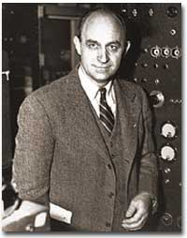 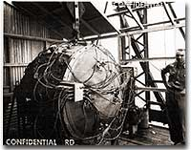 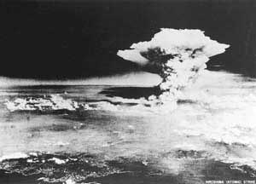

(UShistory.org, 2008)

2008)

(Hiroshima Peace Memorial Museum, 2000)

(UShistory.org, 2008)

In the beginning, the atomic bomb was intended for Germany, but by mid-1944 President Roosevelt and his advisors changed the target to Japan. They hoped the bomb would lead to Japan’s surrender and end the war (Funahashi & Brown, 2011, p. 5).

On August 6, 1945, the United States military dropped an atomic bomb on the city of Hiroshima, Japan. The uranium-based bomb exploded with a force equal to 13,000 tons of TNT. On August 9, three days later, the military dropped a second atomic bomb on Nagasaki, Japan. The plutonium fueled bomb exploded with a force equal to 20,000 tons of TNT. The explosions of these bombs caused intense heat, shock waves, blast winds, and deadly radiation. Approximately 140,000 people in Hiroshima and 70,000 people in Nagasaki died as a result of the bombing (Funahashi & Brown, 2011, p. 5)..

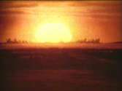 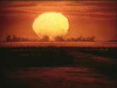 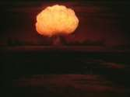

(UShistory.org, 2008)

(UShistory.org, 2008)

(UShistory.org, 2008)

Japan’s Surrender: Japan offered a conditional surrender, and President Harry S. Truman told his cabinet that he did not want to kill any more women and children even though there were plans to drop more atomic bombs on Japan (Funahashi & Brown, 2011, p. 5).

Radiation Effects: Most of deaths from the bombings took place from the time of the drop to the end of 1945; however, bomb survivors continued to die from bomb-related injuries or illnesses for many years. People did not know very much about radiation and its effects on humans when the bombs were dropped. There were many people who survived the explosions, but they were also exposed to significant amounts of intense radiation. A sudden increase in juvenile leukemia occurred in both Hiroshima and Nagasaki after the bombings (Funahashi & Brown, 2011, p. 6).

Sadako Sasaki: Sadako Sasaki was two years old at the time the atomic bomb was dropped on Hiroshima. At the age of twelve, Sadako developed leukemia as a result of her exposure to the radiation from the bomb. During her hospital stay, Sadako’s father told her about a legend that stated her wish for good health could come true if she could fold one thousand paper cranes. She began folding the paper cranes using whatever paper was available including wrapping paper from get-well gifts and medicine-bottle wrappers. Although Sadako folded more than a thousand origami cranes, she succumbed to her illness on October 25, 1955 (Funahashi & Brown, 2011, p. 6).

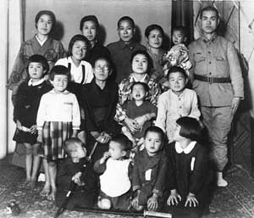 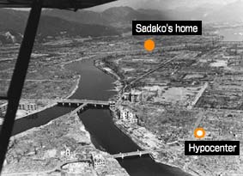 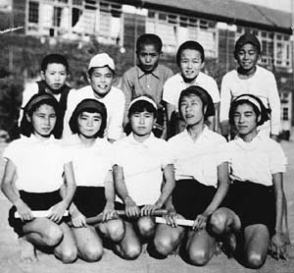

(Hiroshima Peace Memorial Museum, 2000)

(Hiroshima Peace Memorial Museum, 2000)

(Hiroshima Peace Memorial Museum, 2000)

Sadako’s classmates raised funds to create a memorial to her and to all the other children who died as a result of bombing attacks. On the morning of September 11, 2001, Al Qaeda terrorists hijacked airplanes and flew them into both buildings of the World Trade Center in New York City. The impact and damaged caused both towers (110 stories each) to collapse. 2,973 people lost their lives as part of the terrorist attacks including the following public service employees who worked the scene: 343 FDNY firefighters, 23 NYPD police officers, and 37 Port Authority police (Funahashi & Brown, 2011, p. 6).

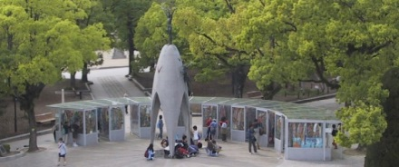 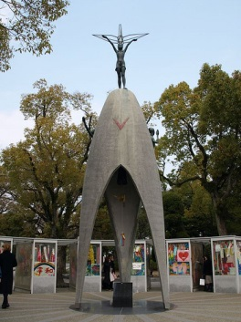 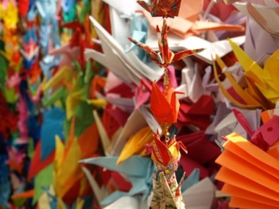

(Atendido, 2013)

(Hiroshima Peace Memorial Museum, 2000)

(The City of Hiroshima, 2001)

The World Trade Center: Twenty-six Japanese citizens died in the September 11th terrorist attacks on the World Trade Center. Families and friends of the lost Fuji Bank employees folded 10,000 paper cranes and sent them to the Tribute WTC Visitor Center (Funahashi & Brown, 2011, p. 7).

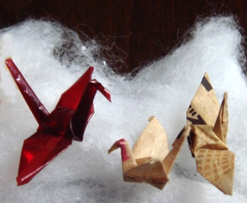 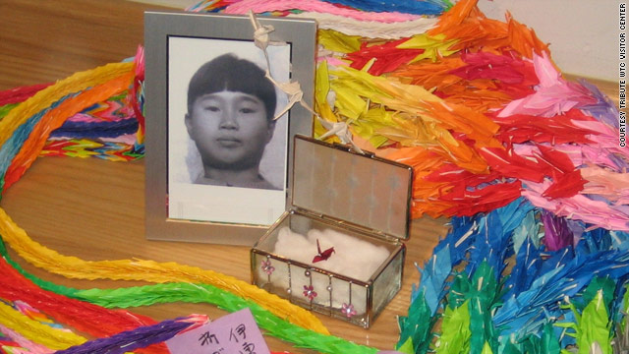

(Minamoto, 2010)

(Drash, 2009)

Sadako’s and the Tribute WTC Visitor Center: In 2007, Sadako’s older brother, Masahiro Sasaki, gave five of Sadako’s paper cranes to places around the world. One of Sadako’s small, red origami cranes was given to the Tribute WTC Visitor Center to be displayed with the chains of 10,000 origami cranes (Funahashi & Brown, 2011, p. 7).

C:\Users\thoak\AppData\Local\Microsoft\Windows\Temporary Internet Files\Content.IE5\9Q2O4UM5\MC900278598[1].wmf

Did any of the questions from the QAR graphic organizer for *Sadako’s Paper Cranes and Lessons of Peace* confuse you? __________________________________________________________________________________________________________________________________________________________________

Did you have any other problems with this story or the question/answer relationship assignment?

_________________________________________________________________________________

# Admit Slip

C:\Users\thoak\AppData\Local\Microsoft\Windows\Temporary Internet Files\Content.IE5\9Q2O4UM5\MC900278598[1].wmf

What literary technique was used in the story *Sadako’s Paper Cranes and Lessons of Peace*? _________________________________________________________________________________

What is the cultural significance of the literary technique used in the story *Sadako’s Paper Cranes and Lessons of Peace*? __________________________________________________________________________________________________________________________________________________________________

# Exit Slip

Problem Solution Outline

|  |  |
| --- | --- |
| Who has the problem? | What is the problem? |
|  |  |
| Why was it a problem? |  |
|  |  |
| Attempted Solutions | Outcomes |
| #1 |  |
| #2 |  |
| End Result |  |

References

Atendido, R. (2013). *The Hiroshima Peace Memorial* [Photograph]. Retrieved from http://www.origami-resource-center.com/sadako.html

Coerr, E. (1997). *Sadako and the thousand paper cranes*. New York, NY: Puffin Books.

Drash, W. (2009, December 17). *Sadako Sasaki, a survivor of the Hiroshima atomic bombing, made this red origami crane while dying of leukemia* [Photograph]. Retrieved from <http://www.cnn.com/2009/LIVING/12/17/origami.gift/index.html?_s=PM:LIVING>

Funahashi, N. & Brown, W. T. (2011). *Sadako’s paper cranes and lessons of peace: Teacher’s guide*. Retrieved from <http://iis-db.stanford.edu/pubs/22665/Sadako_Teacher's_Guide.pdf>

Funahashi, N. (2011). *Sadako’s paper cranes and lessons of peace* [PDF Version]. Retrieved from <http://spice.stanford.edu/catalog/kamishibai_project/>.

Hiroshima Peace Memorial Museum. (2000). *A young girl's death from the A-bomb--Sadako Sasaki, 12 years of age: Sadako's 4,675 days of life*. Retrieved from <http://www.pcf.city.hiroshima.jp/virtual/VirtualMuseum_e/exhibit_e/exh0107_e/exh01071_e.html>

Hiroshima Peace Memorial Museum. (2000). *Fastest Runner in the School* [Photograph]. Retrieved from <http://www.pcf.city.hiroshima.jp/virtual/VirtualMuseum_e/exhibit_e/exh0107_e/exh01071_e.html>

Hiroshima Peace Memorial Museum. (2000). *Sadako's parents hoped she would grow up healthy* [Photograph]. Retrieved from <http://www.pcf.city.hiroshima.jp/virtual/VirtualMuseum_e/exhibit_e/exh0107_e/exh01071_e.html>

Hiroshima Peace Memorial Museum. (2000). *The dropping of the atomic bomb* [Photograph]. Retrieved from <http://www.pcf.city.hiroshima.jp/virtual/VirtualMuseum_e/exhibit_e/exh0107_e/exh01071_e.html>

Hiroshima Peace Memorial Museum. (2000). *Two months after the atomic bombing* [Photograph]. Retrieved from <http://www.pcf.city.hiroshima.jp/virtual/VirtualMuseum_e/exhibit_e/exh0107_e/exh01071_e.html>

Minamoto, K. (2010, August 4). *Three of Sadako's original cranes, one of which can be viewed at the Tribute WTC Visitor* [Photograph]. Retrieved from <http://japansocietyny.blogspot.com/2010/08/sadako-1000-cranes.html>.

Origami Resource Center. (2013). *The Story of Sadako.* Retrieved from http://www.origami-resource-center.com/sadako.html

Stanford University. (n. d.). *Spice Publications*. Retrieved from <http://spice.stanford.edu/catalog/kamishibai_project/>

The City of Hiroshima. (2001). *The children's peace monument* [Photograph]. Retrieved from <http://www.city.hiroshima.lg.jp/shimin/heiwa/monument.html>

UShistory.org (2008). *51f: The Manhattan Project*. Retrieved from <http://www.ushistory.org/us/51f.asp>

Vacca, R. T., Vacca, J. L., & Mraz, M. (2014). *Content area reading:  Literacy and learning across the curriculum*. Boston, MA:  Pearson.

Virginia Department of Education. (2010). *English Standards of Learning for Virginia Public Schools*. Retrieved from http://www.doe.virginia.gov/testing/sol/standards_docs/english/2010/stds_english8.pdf