Galaxies and the Universe

_Nebula_____: Large cloud of gas and dust which can form stars and galaxies.

_Solar Nebula Theory: Stars and planets formed through condensing of the solar nebula.

Galaxy_: Large group of stars, gas, and dust that constitute the universe. By a large group, we mean hundreds of billions.

Most galaxies have a _black hole at their center.

The _Milky Way__ is our galaxy. It is a great disk made of stars orbiting a central point in the disk.

Scientists have used radio waves_ and infrared radiation to determine the shape of the Milky Way.

The Milky Way has a galactic center (called the nucleus) that is surrounded by a _nuclear bulge__ which sticks out of the galactic disk. Surrounding this disk is a set of _spiral arms__.

Three types of galaxies (based on their shape)

- _spiral ____ : Flattened into a disk with spiral arms.
- _elliptical___: Three dimensional and look more like a football
- _irregular__: Does not have a distinct shape.

The Sun

The sun is the largest object in our _solar system.
- Its mass controls the motions of the planets. It contains more than 99.8% of the total mass of the Solar System.
- All energy for our solar comes from the ___sun_____.
- The sun is presently made of 70%_ hydrogen, 28%_ helium , and _2%__ everything else (metals).
- The sun is a _plasma_______: electrically charged particles. Considered the fourth state of matter.

Inside the Sun

- Core
  - Because of the high_ temperature (10,000,000 kelvin – metric unit), the interior of the Sun is gaseous throughout.
  - It is the _densest_______ part of the sun.
  - At this high temperature many of the gases are completely ionized, meaning that the gas has been energized to the point that some of the electrons break free from, but travel with, their nucleus.
  - The sun’s energy comes from nuclear __fusion_______ of hydrogen to helium.

- Radiative zone
  - Energy is transferred from particle to particle by __radiation__________.

- Convection zone
  - In this zone, moving volumes of gas carry the energy the rest of the way to the sun’s surface through _convection____________.

Sun’s Atmosphere
Photosphere
- It is the _lowest____ layer, but most __visible______layer.
- It is _400 km in thickness and the temperature is _5800_ Kelvin.
- It is the most visible layer (even though it’s the lowest layer) because most of the light emitted from the Sun comes from this layer.

Features on the Photosphere
- _Sun_ _spots : Cooler areas on the surface (6,200 F compared to Suns surface of 10,000 F) of the photosphere that appear darker than the surrounding areas on the Sun.
  - Dark and small, but brighter than Full Moon and big as Earth.
  - Associated with __magnetic fields__: one set of spots is positive, other is negative.
  - _solar____ _activity ___ _cycle_____: A period of 22.4 years in which the number of sunspots on the Sun changes regularly and the Sun’s magnetic field reverses.
  - _Galileo____ was the first to observe sunspots. He saw that they moved across the Sun which also showed that the sun was rotating.
- _solar__ __flare___: A sudden eruption of intense high-energy radiation from the sun’s surface.
- _prominence________: Arc of gas ejected from the photosphere.
- _coronal ___holes____: Areas of low density in the gas of the corona from which particles escape.
Chromosphere
- It is _2500km______ in thickness and approximately __30,000_ Kelvin.
- Without special filters, this layer is visible only during a __solar_______ __eclipse____.
Corona
- Top layer of the Sun’s atmosphere. It extends several million kilometers from the top of the chromosphere. It has a temperature range of 1 million____ to 2 million__ Kelvin.
- The _density____ of the gas in the corona is so low that it can only be seen during a total solar eclipse.
  - Gas flows outward from this layer at high speeds and forms the _solar____wind__It is made up of charged particles, or _ions___, which flow outward through the entire solar system.
  - Creates Auroras or Northern and Southern Lights. Electrons from solar wind are captured by the Earth’s magnetic field which interacts with atoms in our atmosphere. Oxygen and nitrogen make red and green; nitrogen can also make violet. Northern lights = Aurora Borealis, Southern = Aurora Australis.

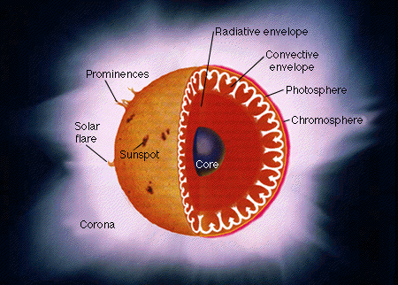

Measuring the Stars
- Stars can be smaller than or up to 2000x larger than the Earth.
- Stars contain different _densities_____.
- Color of a star depends on ___temperature________ and elements.
- Stars form by the _contraction____ of a large sphere of gases which causes the nuclear fusion of _lighter_______ elements into __heavier____ elements.

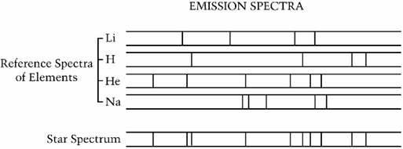

- Astronomers study the composition of stars by measuring their _Spectra____, light spread out in a rainbow band. The spectroscope (which measures the spectra) is fitted into a telescope. When light from the star passes through, it breaks into its component colors. Which two elements in the above star? Hydrogen and helium. The dark lines are caused by elements_ in the star’s atmosphere.
- Light passes through the elements and is absorbed, causing black lines.
- Each element absorbs certain wavelengths, producing a unique pattern of dark lines which are used to identify elements in the star’s atmosphere.
- Most stars (90% of them) that you see are __Main___ _Sequence_____ Stars.
Constellations

- _Constellations_ are groups of stars named after animals, mythological characters, or everyday objects.
- Different constellations appear as Earth revolves around the sun.
- _Polaris____________ (North Star), is the center of the constellation circle, positioned directly over the North Pole. Located at the end of the Little Dipper in the constellation Ursa Minor.
- ___circumpolar _stars__ are constellations that appear year round. As Earth rotates, many constellations circle around Polaris.

Stars Continued

- _Binary__ _stars_ are two stars that are gravitationally bound together and orbit a common center of mass. The bright star _Sirius______ is an example.
- Astronomers use two units of measure for long distances.
  - _Astronomical__ _Unit_____: The distance between Earth and the Sun. 1 AU = 93,000,000 miles.
  - _Light_ __year__: The distance it takes to travel one year. 9.5 trillion kilometers.
- _Parallax__: the apparent shift in a stars position by the motion of the observer. The motion of the observer is the change in position of Earth as it orbits the sun.

Brightness of Stars
- __absolute__ magnitude – The measure of the amount light a star gives off (How bright the star really is)
- __apparent______ magnitude – A measure of the amount of light received on Earth (How bright it looks because it is closer).
- __Luminosity_______ – Energy output from the surface of a star per second; measured in watts.

