Life cycle of a star
__Nebula___________________: clouds of gas and dust.
___Protostar____________________: The attraction of gravity causes particles in the cloud to move towards each other. As they run into each other, they become hot and more dense.
_Main sequence star______________________________: The core temperature rises to about ten million Kelvin, hot enough to convert hydrogen into helium (nuclear fusion). These stars make up about 90% of the stars in the universe. They are of average age (like our sun)
___Red Giant______________: All the hydrogen is used up and has formed helium. The core contracts, the energy produced from the Hydrogen fusion cause the outer layers to expand.
_White Dwarf__________________: Core is made of carbon. Temperature and pressure no longer support outer layers. Giant star collapses.
___Supernova_________________: A massive star becomes so unstable it collapses on itself. The infalling material bounces off the Iron core, the material explodes outward. All that remains is a __neutron star_____________________.
__Black hole_______________________: Results of a supermassive star imploding (20x’s sun’s mass or more). Similar to a supernova; however, the star’s pressure is so great it keeps collapsing in on itself. Gravity is so strong that not even light can escape!
Draw the star cycle below:

Summary: Stars are formed when gas and dust in inner stellar nebula begin to gravitate toward each other. As gas and dust come together, they collide and heat up – expanding the cloud, adding additional Hydrogen and dust to the eventual star. The cloud then cools and condenses once again – gas and dust collide and heat up, expanding the cloud again…. This process continues over and over until the heat of friction becomes high enough for fusion to occur…. Bam!!!! A star is born.
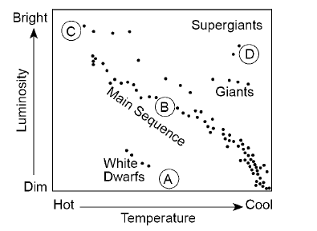
How to read an H-R diagram.
- What is the connection between temperature and luminosity?

Main sequence: as temperature increases, so does luminosity.
Giant stars: as temperature increases, luminosity stays the same…. This is the same for white dwarfs, red giants and supergiants.

- What is the connection between luminosity and size?

As luminosity increases, size increases. In fact, size is the reason luminosity increases.

- How is color related to a star’s temperature?

Cooler stars = red/orange
Hotter stars = Blue/white

Last thought on the universe: From large to small: Superclusters, galaxy clusters, galaxies, Stars, Solar Systems
- Superclusters: made of galaxy clusters.
- Galaxy clusters: made of galaxies
- Galaxies: made of billions of stars which have solar systems

