Name: _________________________ pg. # ________
Air Masses
before we begin what do the following words mean to you?
Maritime _boats, ships, has to do with the water, whaling _
Continental _continents, land __
Polar_cold, ice, polar bears_
Tropical_warm, palm trees, sunny___
------------------------------------------------------------------------------------------------------------------------------------------
In order to determine what type of air mass it is you need to ask two questions
Question #1 Is the air located over land or water?
Continental (c)
An air mass that stays over land for a long time will usually be dry.

Maritime (m)
An air mass that stays over water for a long time will have a lot of moisture. The air here is very humid.

Question #2 Is the air located in a warm or cold area?
Tropical (T) or Polar (P)
Continental Polar
(cP)
This is a cold, dry air mass . It formed over land in a cold location.

Continental Tropical
(cT)
This is a warm dry air mass . It formed over land in a warm location.

Maritime Polar
(mP)
This is a cold humid air mass . It formed over water in a cold location.

Maritime Tropical
(mT)
This is a warm humid air mass . It formed over water in a warm location.

Continental Arctic (cA)
This is a VERY cold and dry air mass. It formed over land in the arctic.

Label the Globe below with the correct air masses
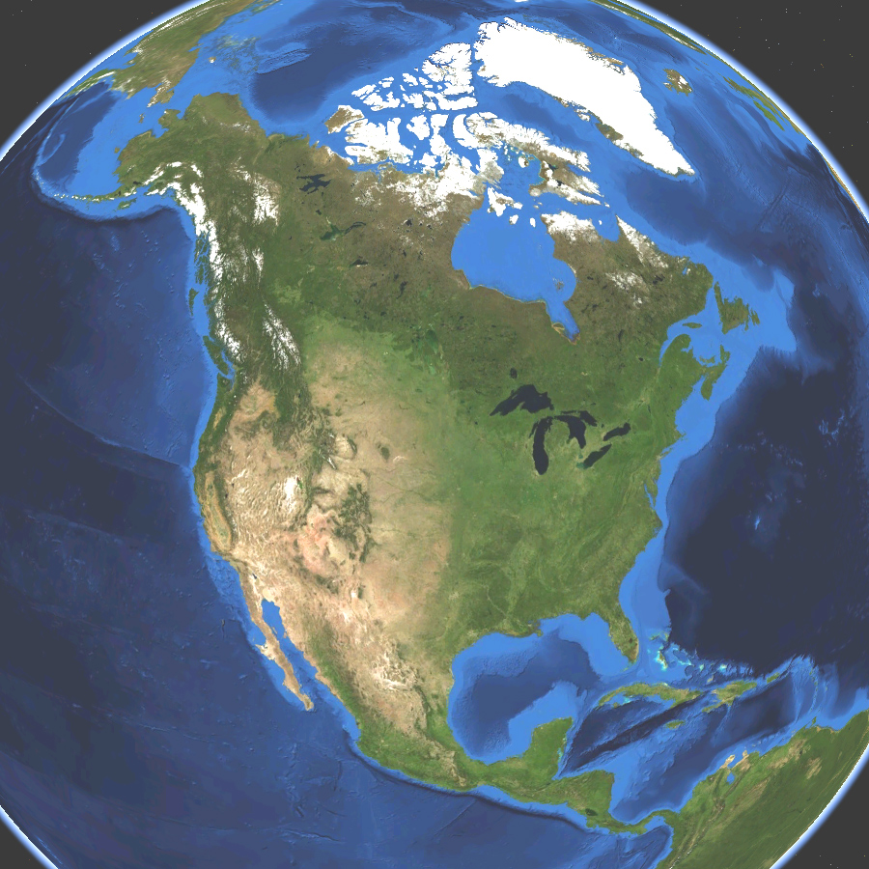
cP
mP
cA
mP
mT
cT
mT
Map Source: NASA

