LESSON PLAN FORMAT

School Site: Middle School Content/Endorsement Area: Special Education/English Grade Level: 6 – 8 Daily Topic: Question Answer Relationships

Unit Topic: Multicultural Literature: An Exploration of Diversity Amongst Cultural Groups

Lesson # _ 2__ (2 of 5)

- Pre-Planning: Academic Foundations/Standards or Benchmarks:
  - Virginia Standards of Learning Objectives
    - Reading
      - 6.5, 8.6 The student will read and demonstrate comprehension of a variety of informational selections.
        - Identify questions to be answered.
        - Make, confirm, or revise predictions.
        - Use context to determine meanings of unfamiliar words and technical vocabulary.
        - Draw conclusions and make inferences based on explicit and implied information.
        - Organize the main idea and details to form a summary.
      - 7.5 The student will read and demonstrate comprehension of a variety of fiction, narrative nonfiction, and poetry.
        - Describe setting, character development, plot structure, theme, and conflict.
        - Draw conclusions based on explicit and implied information.
        - Make inferences based on explicit and implied information.
        - Summarize text.

- Instructional Setting: This lesson was developed for a self-contained class containing sixteen students in the special education program. The classes are 45 minutes long. The students’ desks are arranged in a manner to allow clear vision of the board and the screen for when using the LCD projector and document camera. There are three long cafeteria tables along the back of the room students can use for projects and activities requiring small groups as well as more space. There are seven Ipads and one desktop computer available for student use.

- Goal of the Lesson: The goal of this lesson is for students to learn how to use an anticipation guide prior to reading and a Question-Answer Relationship (QAR) strategy during the reading to help them understand the different types of questions that may accompany texts, whether teacher driven or self-generated, and learn the difference between directly stated and inferred information, as well as higher-order thinking and the relationships found between the text, questions, and prior knowledge (Vacca, Vacca, & Mraz, 2014, p. 204). The teacher and students will go through the attached lesson together to allow the teacher to model the reading strategy similar to a think aloud activity, and then students will complete individual anticipation guides and QARs based on the books they are reading for their independent novel study.

- Behavioral Objectives:
- The Behavior Verb: Each student will answer the QAR questions in complete sentences.
  - P.I.: TBD
- The Condition: While attentively reading the printed background information and the story on the Ipad, each student will answer the questions.
  - P.I.: TBD.
- The Criteria: Upon analyzing the background information and the story, each student will develop responses for all questions.
  - P. I.: TBD

- Integration of other subject areas: This lesson plan parallels the social science content area through its lessons about the history of the atomic bomb, the relationship between the bombing of Hiroshima and a young Japanese girl, and the significance of an ancient Japanese legend and its impact all over world including the Tribute to the World Trade Center Visitor’s Center.

- Differentiation Strategies:
  - Culturally Responsive: Spanish cognates of pertinent vocabulary words will be available to the English Language Learner (ELL). Also, the English language learner will be provided with one-on-one assistance as needed to clarify, understand, and complete the activity.
  - Students will be able to use Ipads in pairs or small groups to read the free PDF version of the Japanese story cards.
  - Students may vary in their responses to higher level questions, and they will be assessed based on individual ability levels, individual grade levels, and within the limitations of the Individualized Education Plans (IEPs)

- Safety considerations:
  - Safety considerations include appropriate use of the technology equipment during the assignment, and safe use of scissors after the assignment.

- Resources, Equipment and Materials:
  - Copies of the attached background information which was teacher generated using Microsoft Word, but based on the original work written by Naomi Funahashi and Waka Takahashi Brown in collaboration with the Stanford Program on International and Cross-Cultural Education (SPICE) made possible by a grant from the United States-Japan Foundation.
  - Copies of the attached teacher generated anticipation guide
  - Copies of the attached teacher generated Question-Answer Relationship Questions
  - Technology:
    - LCD Projector
    - Document Camera
    - Ipad-Download Free PDF file:
Funahashi, N. (2011). Sadako’s paper cranes and lessons of peace. Retrieved from http://spice.stanford.edu/catalog/kamishibai_project/.

  - Origami paper crane instructions (part of above file)
  - Origami paper

- Prerequisites: Students will have prior experience with using an Ipad and graphic organizers.

- Implementation: (Includes time estimates for each section)

- Motivator: (Day 1)
  - Before Reading Activity – Pre-ready Strategy
    - (5 minutes) The teacher will display one of the novels that was available for the independent novel study titled Sadako and the Thousand Paper Cranes. The teacher will explain that students will participate in a new reading strategy under the teacher’s guidance using a Kamishibi, a Japanese card story, based on Sadako’s real life experiences, and then they complete the reading strategies independently with their selected novels.
    - (10 minutes) Students will review the anticipation guide to arouse curiosity and to activate prior knowledge (Vacca, Vacca, & Mraz, 2014, p. 187).

- Procedures: Students will complete the activities in the following order.
  - During Reading Activity (Day 1): 30 minutes
    - Students and teacher will preview the first set of questions on the QAR.
      - The teacher will question students if they have experienced different kinds of reading questions in the past that may be directly stated in the passage, or the information may be implied requiring readers to make predictions, inferences, or decisions based on the information provided.
      - The teacher will ask the students to notice the different types of questions in the left hand column which indicate if the answer is found in the text, or if they need to form their own response.
    - The teacher will orally read the sections labeled introduction, history, and radiation effects and pause after each paragraph to ask for volunteers to summarize the information.
      - During the reading, the teacher will ask for a new volunteer to locate the answer to the first question and point out the directly stated answer on the handout under the document camera.
      - The teacher will continue this pattern for the first set of questions in efforts to model how to locate information in the reading passage to answer questions.
      - The teacher will walk the students through the critical thinking questions in the first section in a think aloud format to model how to read the information, think about what the author is saying, and make inferences or decisions based on the content and prior knowledge.
  - During Reading Activity (Day 2): 40 minutes
    - First 20 minutes
      - Students will work in pairs and read the electronic (PDF) version of the Kamishibi story (a Japanese card story) Sadako’s Paper Cranes and Lessons of Peace.
      - Students will collaborate together to complete the second set of questions.
    - Second 20 minutes
      - Students will return to their desks and read the remaining background handout under the teacher’s guidance.
    - Students will use the handout and the electronic stories to independently answer the third set of questions.
  - After Reading Activity (Day 2): 5 minutes
    - Students will return to the anticipation guide to make necessary corrections of their initial responses to anticipatory questions.
- Closure (Day 3): Time will vary depending on quality of responses – 20 to 45 minutes
  - The teacher will briefly check responses after day two for complete sentences and return to students on day three to provide additional time to answer any incomplete questions.
  - One-on-one reinforcement will be provided as needed.
  - Once the criteria has been fulfilled, including giving a correct response for the last question about the literary technique of symbols, students will be allowed to select a decorative piece of origami paper and follow the instructions provided in the story to build a crane.

Background Information: Sadako's Paper Cranes and Lessons of Peace

Introduction: In 2007, a Japanese man by the name of Masahiro Sasaki presented a gift of an origami paper crane to the Tribute World Trade Center Visitor Center in New York City (Funahashi & Brown, 2011, p. 5).

History: The Manhattan Project began in 1941, during World War II. President Franklin Delano Roosevelt was encouraged by scientists to start the Manhattan Project in efforts to create the first atomic bomb before Nazi Germany did. The Manhattan Project, which cost nearly $2 billion, was kept as a secret between the President and his top advisors (Funahashi & Brown, 2011, p. 5).

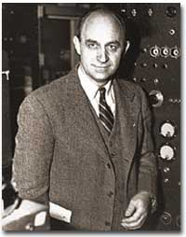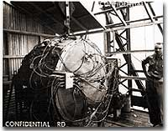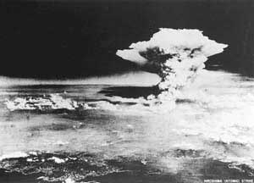
(UShistory.org, 2008)
2008)
(Hiroshima Peace Memorial Museum, 2000)
(UShistory.org, 2008)

In the beginning, the atomic bomb was intended for Germany, but by mid-1944 President Roosevelt and his advisors changed the target to Japan. They hoped the bomb would lead to Japan’s surrender and end the war (Funahashi & Brown, 2011, p. 5).

On August 6, 1945, the United States military dropped an atomic bomb on the city of Hiroshima, Japan. The uranium-based bomb exploded with a force equal to 13,000 tons of TNT. On August 9, three days later, the military dropped a second atomic bomb on Nagasaki, Japan. The plutonium fueled bomb exploded with a force equal to 20,000 tons of TNT. The explosions of these bombs caused intense heat, shock waves, blast winds, and deadly radiation. Approximately 140,000 people in Hiroshima and 70,000 people in Nagasaki died as a result of the bombing (Funahashi & Brown, 2011, p. 5)..

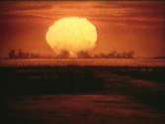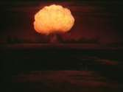
(UShistory.org, 2008)

(UShistory.org, 2008)

(UShistory.org, 2008)

Japan’s Surrender: Japan offered a conditional surrender, and President Harry S. Truman told his cabinet that he did not want to kill any more women and children even though there were plans to drop more atomic bombs on Japan (Funahashi & Brown, 2011, p. 5).

Radiation Effects: Most of deaths from the bombings took place from the time of the drop to the end of 1945; however, bomb survivors continued to die from bomb-related injuries or illnesses for many years. People did not know very much about radiation and its effects on humans when the bombs were dropped. There were many people who survived the explosions, but they were also exposed to significant amounts of intense radiation. A sudden increase in juvenile leukemia occurred in both Hiroshima and Nagasaki after the bombings (Funahashi & Brown, 2011, p. 6).

Sadako Sasaki: Sadako Sasaki was two years old at the time the atomic bomb was dropped on Hiroshima. At the age of twelve, Sadako developed leukemia as a result of her exposure to the radiation from the bomb. During her hospital stay, Sadako’s father told her about a legend that stated her wish for good health could come true if she could fold one thousand paper cranes. She began folding the paper cranes using whatever paper was available including wrapping paper from get-well gifts and medicine-bottle wrappers. Although Sadako folded more than a thousand origami cranes, she succumbed to her illness on October 25, 1955 (Funahashi & Brown, 2011, p. 6).
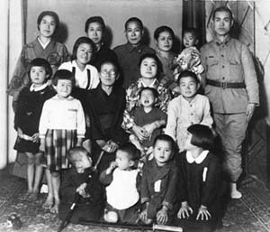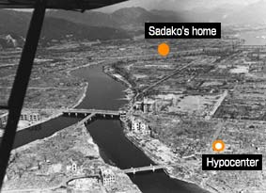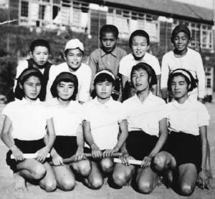
(Hiroshima Peace Memorial Museum, 2000)
(Hiroshima Peace Memorial Museum, 2000)
(Hiroshima Peace Memorial Museum, 2000)

Sadako’s classmates raised funds to create a memorial to her and to all the other children who died as a result of bombing attacks. On the morning of September 11, 2001, Al Qaeda terrorists hijacked airplanes and flew them into both buildings of the World Trade Center in New York City. The impact and damaged caused both towers (110 stories each) to collapse. 2,973 people lost their lives as part of the terrorist attacks including the following public service employees who worked the scene: 343 FDNY firefighters, 23 NYPD police officers, and 37 Port Authority police (Funahashi & Brown, 2011, p. 6).

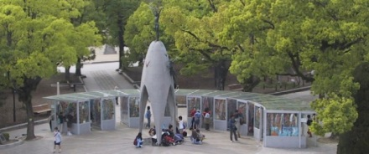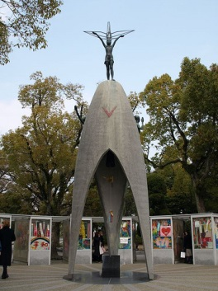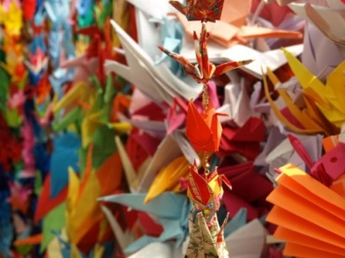
(Atendido, 2013)
(Hiroshima Peace Memorial Museum, 2000)
(The City of Hiroshima, 2001)
The World Trade Center: Twenty-six Japanese citizens died in the September 11th terrorist attacks on the World Trade Center. Families and friends of the lost Fuji Bank employees folded 10,000 paper cranes and sent them to the Tribute WTC Visitor Center (Funahashi & Brown, 2011, p. 7).

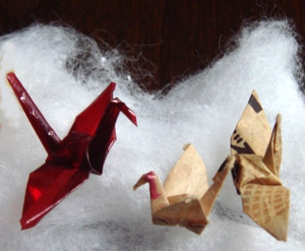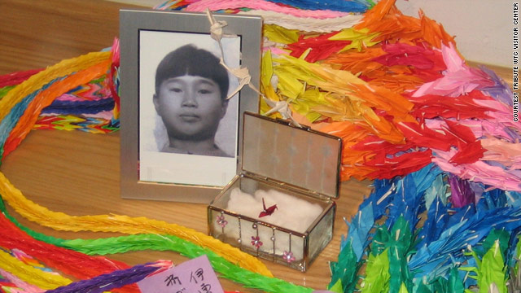
(Minamoto, 2010)
(Drash, 2009)

Sadako’s and the Tribute WTC Visitor Center: In 2007, Sadako’s older brother, Masahiro Sasaki, gave five of Sadako’s paper cranes to places around the world. One of Sadako’s small, red origami cranes was given to the Tribute WTC Visitor Center to be displayed with the chains of 10,000 origami cranes (Funahashi & Brown, 2011, p. 7).

Anticipation Guide
Sadako's Paper Cranes and Lessons of Peace

Directions: Read each of the following statements and in the “Before Reading” column, place a plus (+) if you agree with the statement and a minus (-) if you disagree. After reading Sadako's Paper Cranes and Lessons of Peace, you will complete the “After Reading” column to see if any of your initial responses have changed.

Before Reading | Statement | After Reading
 | The Manhattan Project was a beautification project in New York City, New York.
 | The Manhattan Project was a top secret project between President Franklin Delano Roosevelt and his top advisors.
 | The Manhattan Project was encouraged by scientists in efforts to create the first atomic bomb during World War II.
 | On August 6, 1945, the United States dropped an atomic bomb on the city of Hiroshima, Japan, but it was a bust and nearly caused us to lose war.
 | The United States actually dropped two bombs three days apart. One was in Hiroshima, and one was in Nagasaki.
 | It is impossible for people to survive an atomic bomb.
 | People can survive atomic bombs, but suffer from the effects of radiation afterwards.
 | Sadako Sasaki was two year old child who survived an atomic bomb.
 | Sadako Sasaki developed leukemia as a result of exposure to radiation from an atomic bomb.
 | The origami crane is a symbol of death.
 | According to Japanese tradition, anyone with the patience and commitment to fold 1,000 paper cranes will be granted their most desired wish.
 | Sadako folded 1,000 cranes, but died anyway.
 | Because Sadako’s family was poor, they could not afford a memorial, and she was forgotten by everyone.
 | Sadako’s origami cranes were burned because they did save her.
 | The statue of a young girl holding a crane is a symbol for world peace.

Question-Answer Relationships
Sadako's Paper Cranes and Lessons of Peace

Directions: Answer the following questions which may be directly stated in the text, inferred in the text, implied by the author, or based on your own thoughts about the text.

Type of question | Question | Answer
 | The Manhattan Project
In the text – Right There | What world event was happening during 1941 when the Manhattan Project began?
In the text – Think & Search | What was the purpose of the Manhattan Project?
In your head –  Author & You | Why was the Manhattan Project kept as a secret?
In your head – On Your Own | What other alternatives could have been explored to end the war to eliminate so many people, such as children, getting killed?
 | Sadako Sasaki
In the text – Right There | How old was Sadako Sasaki when the atomic bomb hit, and where did she live (city & country).
In the text – Think & Search | How was the atomic bomb related to Sadako’s illness?
In your head –  Author & You | Why did Sadako’s father get her hopes up by telling her about the ancient Japanese legend?
In your head – On Your Own | What is the cultural significance of the 1000 origami cranes?

Sadako's Paper Cranes
and Lessons of Peace
In the text – Right There | What materials did Sadako use to fold the paper cranes?
In the text – Think & Search | Why did Sadako’s friends work so hard to raise money for her memorial?
In your head –  Author & You | What is the significance of the Children’s Peace Monument?
In your head – On Your Own | Why do people continue to make origami cranes and send them to the Children’s Peace Monument and other locations around the world?
Japan’s link to the
World Trade Center (WTC)
In the text – Right There | Who (name & relationship) donated one of Sadako’s origami cranes to the World Trade Center’s Visitor Center?
In the text – Think & Search | What was the purpose of donating Sadako’s origami crane to the WTC visitor’s center?
In your head –  Author & You | The author stated that Sadako folded the origami cranes to keep her spirit and hopes alive. How was the ancient Japanese legend fulfilled?
In your head – On Your Own | First, what literary technique have we studied that the origami crane serves as? Second, what is the relationship between the crane and the literary technique?

References
Atendido, R. (2013). The Hiroshima Peace Memorial [Photograph]. Retrieved from http://www.origami-resource-center.com/sadako.html
Coerr, E. (1997). Sadako and the thousand paper cranes. New York, NY: Puffin Books.
Drash, W. (2009, December 17). Sadako Sasaki, a survivor of the Hiroshima atomic bombing, made this red origami crane while dying of leukemia [Photograph]. Retrieved from http://www.cnn.com/2009/LIVING/12/17/origami.gift/index.html?_s=PM:LIVING
Funahashi, N. & Brown, W. T. (2011). Sadako’s paper cranes and lessons of peace: Teacher’s guide. Retrieved from http://iis-db.stanford.edu/pubs/22665/Sadako_Teacher's_Guide.pdf
Funahashi, N. (2011). Sadako’s paper cranes and lessons of peace [PDF Version]. Retrieved from http://spice.stanford.edu/catalog/kamishibai_project/.
Hiroshima Peace Memorial Museum. (2000). A young girl's death from the A-bomb--Sadako Sasaki, 12 years of age: Sadako's 4,675 days of life. Retrieved from http://www.pcf.city.hiroshima.jp/virtual/VirtualMuseum_e/exhibit_e/exh0107_e/exh01071_e.html
Hiroshima Peace Memorial Museum. (2000). Fastest Runner in the School [Photograph]. Retrieved from http://www.pcf.city.hiroshima.jp/virtual/VirtualMuseum_e/exhibit_e/exh0107_e/exh01071_e.html
Hiroshima Peace Memorial Museum. (2000). Sadako's parents hoped she would grow up healthy [Photograph]. Retrieved from http://www.pcf.city.hiroshima.jp/virtual/VirtualMuseum_e/exhibit_e/exh0107_e/exh01071_e.html
Hiroshima Peace Memorial Museum. (2000). The dropping of the atomic bomb [Photograph]. Retrieved from http://www.pcf.city.hiroshima.jp/virtual/VirtualMuseum_e/exhibit_e/exh0107_e/exh01071_e.html
Hiroshima Peace Memorial Museum. (2000). Two months after the atomic bombing [Photograph]. Retrieved from http://www.pcf.city.hiroshima.jp/virtual/VirtualMuseum_e/exhibit_e/exh0107_e/exh01071_e.html
Minamoto, K. (2010, August 4). Three of Sadako's original cranes, one of which can be viewed at the Tribute WTC Visitor [Photograph]. Retrieved from http://japansocietyny.blogspot.com/2010/08/sadako-1000-cranes.html.
Origami Resource Center. (2013). The Story of Sadako. Retrieved from http://www.origami-resource-center.com/sadako.html
Stanford University. (n. d.). Spice Publications. Retrieved from http://spice.stanford.edu/catalog/kamishibai_project/
The City of Hiroshima. (2001). The children's peace monument [Photograph]. Retrieved from http://www.city.hiroshima.lg.jp/shimin/heiwa/monument.html
UShistory.org (2008). 51f: The Manhattan Project. Retrieved from http://www.ushistory.org/us/51f.asp
Vacca, R. T., Vacca, J. L., & Mraz, M. (2014). Content area reading: Literacy and learning across the curriculum. Boston, MA: Pearson.
Virginia Department of Education. (2010). English Standards of Learning for Virginia Public Schools. Retrieved from http://www.doe.virginia.gov/testing/sol/standards_docs/english/2010/stds_english8.pdf

