LESSON PLAN FORMAT

School Site: Middle School Content/Endorsement Area: Special Education/English Grade Level: 6 – 8 Daily Topic: Vocabulary

Unit Topic: Multicultural Literature: An Exploration of Diversity Amongst Cultural Groups

Lesson # _ 4__ (4 of 5)

* **Pre-Planning**: Academic Foundations/Standards or Benchmarks**:** 
  + Virginia Standards of Learning Objectives
    - Reading
      * 6.5, 8.6 The student will read and demonstrate comprehension of a variety of informational selections.
        + Identify questions to be answered.
        + Make, confirm, or revise predictions.
        + Use context to determine meanings of unfamiliar words and technical vocabulary.
        + Draw conclusions and make inferences based on explicit and implied information.
        + Organize the main idea and details to form a summary.
      * 7.5 The student will read and demonstrate comprehension of a variety of fiction, narrative nonfiction, and poetry.
        + Describe setting, character development, plot structure, theme, and conflict.
        + Draw conclusions based on explicit and implied information.
        + Make inferences based on explicit and implied information.
        + Summarize text.
* **Instructional Setting**: This lesson was developed for a self-contained class containing sixteen students in the special education program. The classes are 45 minutes long. The students’ desks are arranged in a manner to allow clear vision of the board and the screen for when using the LCD projector and document camera. There are three long cafeteria tables along the back of the room students can use for projects and activities requiring small groups as well as more space. There are seven Ipads and one desktop computer available for student use.
* **Goal of the Lesson**: The goal of this lesson is for students to increase their comprehension of the text by using a study guide to support the organization of the text structure and focus on essential concepts (Vacca, Vacca, & Mraz, 2014, p. 337). The teacher and students will work on the study together to allow students an opportunity to learn how to use the strategy, and then students will independently complete the strategy using words from their independent novel study.
* **Behavioral Objectives**:

1. The Behavior Verb: Each student will participate in the study guide strategy.
   1. P.I.: **TBD**
2. The Condition: While working collaboratively with others, students will complete the study guide.
   1. P.I.: **TBD**.
3. The Criteria: Upon analyzing the background information and the story, each student will complete the study guide.
   1. P. I.: **TBD**

* **Integration of other subject areas**: This lesson plan parallels the social science content area through its lessons about the history of the atomic bomb, the relationship between the bombing of Hiroshima and a young Japanese girl, and the significance of an ancient Japanese legend and its impact all over world including the Tribute to the World Trade Center Visitor’s Center.
* **Differentiation Strategies**:
  + Culturally Responsive: Spanish cognates of pertinent vocabulary words will be available to the English Language Learner (ELL). Also, the English language learner will be provided with one-on-one assistance as needed to clarify, understand, and complete the activity.
  + Students will be able to use Ipads in pairs or small groups to read the free PDF version of the Japanese story cards.
  + Students will work in cooperative learning groups to complete the study guide.
* **Safety considerations**:
  + Safety considerations include appropriate use of the technology equipment during the assignment, and safe use of glue during the assignment.
* **Resources, Equipment and Materials**:
  + Copies of the attached background information which was teacher generated using Microsoft Word, but based on the original work written by Naomi Funahashi and Waka Takahashi Brown in collaboration with the Stanford Program on International and Cross-Cultural Education (SPICE) made possible by a grant from the United States-Japan Foundation.
  + Copies of the admit slip
  + Copies of the exit slip
  + Copies of the study guide
  + Technology:
    - Ipad-Download Free PDF file:

Funahashi, N. (2011)*. Sadako’s paper cranes and lessons of peace.* Retrieved from <http://spice.stanford.edu/catalog/kamishibai_project/>*.*

* **Prerequisites**: Students will have completed all of the reading activities from the previous lessons. Students will have prior experience using the Ipad and graphic organizers.
* **Implementation**: (Includes time estimates for each section)
* **Motivator**:
  + **Before Reading Activity** – Admit Slip (10 minutes)
    - Students will complete an admit slip to answer selective reading guide questions from *Sadako’s Paper Cranes and Lessons of Peace* (Vacca, Vacca, & Mraz, 2014, p. 339).
* **Procedures**:
  + **During Reading Activity**: Cause and Effect Study Guide (30 minutes)
    - Students and teacher will preview and discuss the structure of the study guide.
    - Students will work together in cooperative learning groups to review the reading materials, analyze the text structure, and determine cause and effect relationships (Vacca, Vacca, & Mraz, 2014, p. 339).
* **Closure**
  + **After Reading Activity**: Exit Slip - (5 minutes)
    - Students will complete a higher order thinking exit slip to bring closure to the activity (Vacca, Vacca, & Mraz, 2014, p. 290).

References

Atendido, R. (2013). *The Hiroshima Peace Memorial* [Photograph]. Retrieved from http://www.origami-resource-center.com/sadako.html

Coerr, E. (1997). *Sadako and the thousand paper cranes*. New York, NY: Puffin Books.

Drash, W. (2009, December 17). *Sadako Sasaki, a survivor of the Hiroshima atomic bombing, made this red origami crane while dying of leukemia* [Photograph]. Retrieved from <http://www.cnn.com/2009/LIVING/12/17/origami.gift/index.html?_s=PM:LIVING>

Funahashi, N. & Brown, W. T. (2011). *Sadako’s paper cranes and lessons of peace: Teacher’s guide*. Retrieved from <http://iis-db.stanford.edu/pubs/22665/Sadako_Teacher's_Guide.pdf>

Funahashi, N. (2011). *Sadako’s paper cranes and lessons of peace* [PDF Version]. Retrieved from <http://spice.stanford.edu/catalog/kamishibai_project/>.

Hiroshima Peace Memorial Museum. (2000). *A young girl's death from the A-bomb--Sadako Sasaki, 12 years of age: Sadako's 4,675 days of life*. Retrieved from <http://www.pcf.city.hiroshima.jp/virtual/VirtualMuseum_e/exhibit_e/exh0107_e/exh01071_e.html>

Hiroshima Peace Memorial Museum. (2000). *Fastest Runner in the School* [Photograph]. Retrieved from <http://www.pcf.city.hiroshima.jp/virtual/VirtualMuseum_e/exhibit_e/exh0107_e/exh01071_e.html>

Hiroshima Peace Memorial Museum. (2000). *Sadako's parents hoped she would grow up healthy* [Photograph]. Retrieved from <http://www.pcf.city.hiroshima.jp/virtual/VirtualMuseum_e/exhibit_e/exh0107_e/exh01071_e.html>

Hiroshima Peace Memorial Museum. (2000). *The dropping of the atomic bomb* [Photograph]. Retrieved from <http://www.pcf.city.hiroshima.jp/virtual/VirtualMuseum_e/exhibit_e/exh0107_e/exh01071_e.html>

Hiroshima Peace Memorial Museum. (2000). *Two months after the atomic bombing* [Photograph]. Retrieved from <http://www.pcf.city.hiroshima.jp/virtual/VirtualMuseum_e/exhibit_e/exh0107_e/exh01071_e.html>

Minamoto, K. (2010, August 4). *Three of Sadako's original cranes, one of which can be viewed at the Tribute WTC Visitor* [Photograph]. Retrieved from <http://japansocietyny.blogspot.com/2010/08/sadako-1000-cranes.html>.

Origami Resource Center. (2013). *The Story of Sadako.* Retrieved from http://www.origami-resource-center.com/sadako.html

Stanford University. (n. d.). *Spice Publications*. Retrieved from <http://spice.stanford.edu/catalog/kamishibai_project/>

The City of Hiroshima. (2001). *The children's peace monument* [Photograph]. Retrieved from <http://www.city.hiroshima.lg.jp/shimin/heiwa/monument.html>

UShistory.org (2008). *51f: The Manhattan Project*. Retrieved from <http://www.ushistory.org/us/51f.asp>

Vacca, R. T., Vacca, J. L., & Mraz, M. (2014). *Content area reading:  Literacy and learning across the curriculum*. Boston, MA:  Pearson.

Virginia Department of Education. (2010). *English Standards of Learning for Virginia Public Schools*. Retrieved from http://www.doe.virginia.gov/testing/sol/standards_docs/english/2010/stds_english8.pdf

**Background Information: Sadako's Paper Cranes and Lessons of Peace**

Introduction: In 2007, a Japanese man by the name of Masahiro Sasaki presented a gift of an origami paper crane to the Tribute World Trade Center Visitor Center in New York City (Funahashi & Brown, 2011, p. 5).

History: The Manhattan Project began in 1941, during World War II. President Franklin Delano Roosevelt was encouraged by scientists to start the Manhattan Project in efforts to create the first atomic bomb before Nazi Germany did. The Manhattan Project, which cost nearly $2 billion, was kept as a secret between the President and his top advisors (Funahashi & Brown, 2011, p. 5).

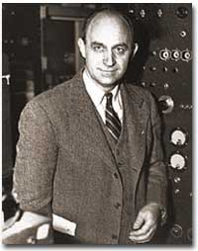 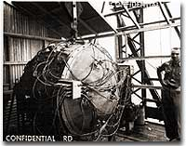 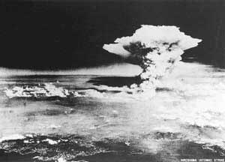

(UShistory.org, 2008)

2008)

(Hiroshima Peace Memorial Museum, 2000)

(UShistory.org, 2008)

In the beginning, the atomic bomb was intended for Germany, but by mid-1944 President Roosevelt and his advisors changed the target to Japan. They hoped the bomb would lead to Japan’s surrender and end the war (Funahashi & Brown, 2011, p. 5).

On August 6, 1945, the United States military dropped an atomic bomb on the city of Hiroshima, Japan. The uranium-based bomb exploded with a force equal to 13,000 tons of TNT. On August 9, three days later, the military dropped a second atomic bomb on Nagasaki, Japan. The plutonium fueled bomb exploded with a force equal to 20,000 tons of TNT. The explosions of these bombs caused intense heat, shock waves, blast winds, and deadly radiation. Approximately 140,000 people in Hiroshima and 70,000 people in Nagasaki died as a result of the bombing (Funahashi & Brown, 2011, p. 5)..

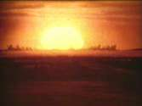 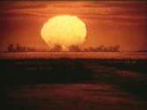 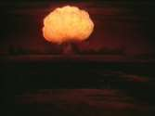

(UShistory.org, 2008)

(UShistory.org, 2008)

(UShistory.org, 2008)

Japan’s Surrender: Japan offered a conditional surrender, and President Harry S. Truman told his cabinet that he did not want to kill any more women and children even though there were plans to drop more atomic bombs on Japan (Funahashi & Brown, 2011, p. 5).

Radiation Effects: Most of deaths from the bombings took place from the time of the drop to the end of 1945; however, bomb survivors continued to die from bomb-related injuries or illnesses for many years. People did not know very much about radiation and its effects on humans when the bombs were dropped. There were many people who survived the explosions, but they were also exposed to significant amounts of intense radiation. A sudden increase in juvenile leukemia occurred in both Hiroshima and Nagasaki after the bombings (Funahashi & Brown, 2011, p. 6).

Sadako Sasaki: Sadako Sasaki was two years old at the time the atomic bomb was dropped on Hiroshima. At the age of eleven, Sadako developed leukemia as a result of her exposure to the radiation from the bomb. During her hospital stay, Sadako’s father told her about a legend that stated her wish for good health could come true if she could fold one thousand paper cranes. She began folding the paper cranes using whatever paper was available including wrapping paper from get-well gifts and medicine-bottle wrappers. Although Sadako folded more than a thousand origami cranes, she succumbed to her illness on October 25, 1955 (Funahashi & Brown, 2011, p. 6).

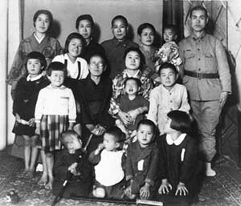 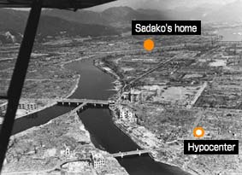 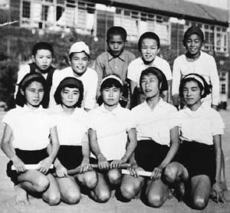

(Hiroshima Peace Memorial Museum, 2000)

(Hiroshima Peace Memorial Museum, 2000)

(Hiroshima Peace Memorial Museum, 2000)

Sadako’s classmates raised funds to create a memorial to her and to all the other children who died as a result of bombing attacks. On the morning of September 11, 2001, Al Qaeda terrorists hijacked airplanes and flew them into both buildings of the World Trade Center in New York City. The impact and damaged caused both towers (110 stories each) to collapse. 2,973 people lost their lives as part of the terrorist attacks including the following public service employees who worked the scene: 343 FDNY firefighters, 23 NYPD police officers, and 37 Port Authority police (Funahashi & Brown, 2011, p. 6).

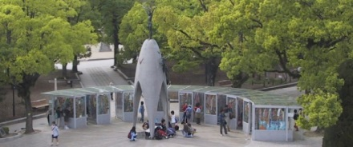 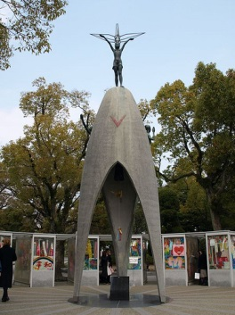 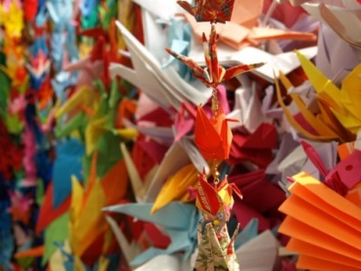

(Atendido, 2013)

(Hiroshima Peace Memorial Museum, 2000)

(The City of Hiroshima, 2001)

The World Trade Center: Twenty-six Japanese citizens died in the September 11th terrorist attacks on the World Trade Center. Families and friends of the lost Fuji Bank employees folded 10,000 paper cranes and sent them to the Tribute WTC Visitor Center (Funahashi & Brown, 2011, p. 7).

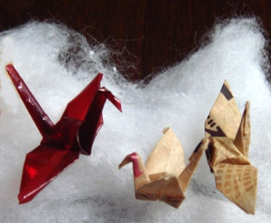 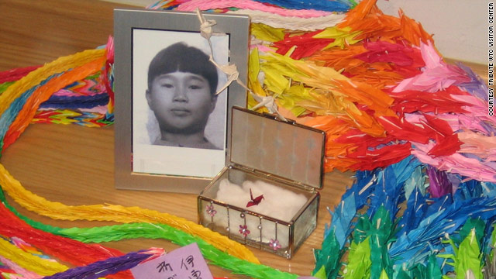

(Minamoto, 2010)

(Drash, 2009)

Sadako’s and the Tribute WTC Visitor Center: In 2007, Sadako’s older brother, Masahiro Sasaki, gave five of Sadako’s paper cranes to places around the world. One of Sadako’s small, red origami cranes was given to the Tribute WTC Visitor Center to be displayed with the chains of 10,000 origami cranes (Funahashi & Brown, 2011, p. 7).

C:\Users\thoak\AppData\Local\Microsoft\Windows\Temporary Internet Files\Content.IE5\9Q2O4UM5\MC900278598[1].wmf

**Directions**: Use the story *Sadako’s Paper Pranes and Lessons of Peace* to answer the following questions:

1. The United States dropped an atomic bomb on Hiroshima, Japan on August 6, 1945 in efforts to end World War II.
   1. True b. False
2. No one knows how or why Sadako Sasaki developed juvenile leukemia at the age of 11.
   1. True b. False
3. Sadako’s father told her of an ancient legend that would grant her wish true if she folded 1000 origami cranes
   1. True b. False

# Admit Slip

C:\Users\thoak\AppData\Local\Microsoft\Windows\Temporary Internet Files\Content.IE5\9Q2O4UM5\MC900278598[1].wmf

Directions: These answers are not directly stated by the author. You must read beyond the lines.

1. Why is Sadako’s story important to people around the world? ____________________________________________________________________________________________________________________________________________________
2. What literary technique does the crane used in the story *Sadako’s Paper Cranes and Lessons of Peace* represent? __________________________________________________________________________________________________________________________________________________________________

# Exit Slip

Cause & Effect Study Guide

Instructions: Select from the “causes” column on the left the cause that led to the effect in the “effects” column on the right. Put the letter of each effect next to its cause in the space provided.

|  |  |  |
| --- | --- | --- |
| Answer | Cause | Effect |
|  | 1. 1. In 1941, during World War II, President Franklin Delano Roosevelt was encouraged by scientists to create the first atomic bomb before Nazi Germany did. 2. 2. President Roosevelt and his advisors wanted Japan to surrender and end the war. 3. 3. The uranium-based bomb dropped on Hiroshima exploded with a force equal to 13,000 tons of TNT. The plutonium fueled bomb dropped on Nagasaki exploded with a force equal to 20,000 tons of TNT. 4. 4. There were many people who survived the explosions, but they were also exposed to significant amounts of intense radiation. 5. 5. Sadako Sasaki was two years old at the time the atomic bomb was dropped on Hiroshima, and she was exposed to deadly radiation. 6. 6. Sadako’s father told her about a legend that stated her wish for good health could come true if she could fold one thousand paper cranes. 7. 7. Sadako succumbed to her illness just like many other children who were exposed to the radiation from the bombs. 8. 8. On the morning of September 11, 2001, Al Qaeda terrorists hijacked airplanes and flew them into both buildings of the World Trade Center in New York City. 9. 9. Twenty-six Japanese citizens died in the September 11th terrorist attacks on the World Trade Center. 10. 10. In 2007, a Japanese man by the name of Masahiro Sasaki presented one of Sadako’s original origami paper cranes to the Tribute World Trade Center Visitor Center in New York City | 1. A. Bomb survivors continued to die from bomb-related injuries or illnesses for many years.   B. Bombs were dropped on Hiroshima and Nagasaki  C. At the age of eleven, Sadako developed leukemia.  D. Sadako’s classmates raised funds to create a memorial to her and to all the other children who died as a result of bombing attacks.  E. The Manhattan Project  F. Families and friends of the lost Fuji Bank employees folded 10,000 paper cranes and sent them to the Tribute WTC Visitor Center  G. Sadako began folding the paper cranes using whatever paper was available including wrapping paper from get-well gifts and medicine-bottle wrappers.  H. The impact and damaged caused both towers (110 stories each) to collapse. 2,973 people lost their lives as part of the terrorist attacks.  I. Sadako’s cranes serve “symbol of the Sasaki family’s hopes for compassion and peace.”  J. The explosions caused intense heat, shock waves, blast winds, and deadly radiation causing the deaths of 210,000 people. |