Background Information: Sadako's Paper Cranes and Lessons of Peace
(Minamoto, 2010)
(Drash, 2009)
Introduction: In 2007, a Japanese man by the name of Masahiro Sasaki presented a gift of an origami paper crane to the Tribute World Trade Center Visitor Center in New York City (Funahashi & Brown, 2011, p. 5).

History: The Manhattan Project began in 1941, during World War II. President Franklin Delano Roosevelt was encouraged by scientists to start the Manhattan Project in efforts to create the first atomic bomb before Nazi Germany did. The Manhattan Project, which cost nearly $2 billion, was kept as a secret between the President and his top advisors (Funahashi & Brown, 2011, p. 5).

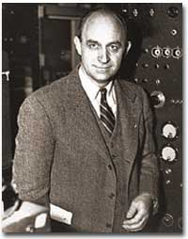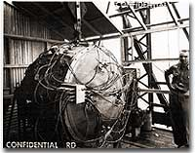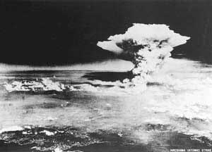
(UShistory.org, 2008)
2008)
(Hiroshima Peace Memorial Museum, 2000)
(UShistory.org, 2008)

In the beginning, the atomic bomb was intended for Germany, but by mid-1944 President Roosevelt and his advisors changed the target to Japan. They hoped the bomb would lead to Japan’s surrender and end the war (Funahashi & Brown, 2011, p. 5).

On August 6, 1945, the United States military dropped an atomic bomb on the city of Hiroshima, Japan. The uranium-based bomb exploded with a force equal to 13,000 tons of TNT. On August 9, three days later, the military dropped a second atomic bomb on Nagasaki, Japan. The plutonium fueled bomb exploded with a force equal to 20,000 tons of TNT. The explosions of these bombs caused intense heat, shock waves, blast winds, and deadly radiation. Approximately 140,000 people in Hiroshima and 70,000 people in Nagasaki died as a result of the bombing (Funahashi & Brown, 2011, p. 5)..

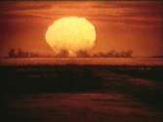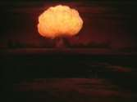
(UShistory.org, 2008)

(UShistory.org, 2008)

(UShistory.org, 2008)

Japan’s Surrender: Japan offered a conditional surrender, and President Harry S. Truman told his cabinet that he did not want to kill any more women and children even though there were plans to drop more atomic bombs on Japan (Funahashi & Brown, 2011, p. 5).

Radiation Effects: Most of deaths from the bombings took place from the time of the drop to the end of 1945; however, bomb survivors continued to die from bomb-related injuries or illnesses for many years. People did not know very much about radiation and its effects on humans when the bombs were dropped. There were many people who survived the explosions, but they were also exposed to significant amounts of intense radiation. A sudden increase in juvenile leukemia occurred in both Hiroshima and Nagasaki after the bombings (Funahashi & Brown, 2011, p. 6).

Sadako Sasaki: Sadako Sasaki was two years old at the time the atomic bomb was dropped on Hiroshima. At the age of eleven, Sadako developed leukemia as a result of her exposure to the radiation from the bomb. During her hospital stay, Sadako’s father told her about a legend that stated her wish for good health could come true if she could fold one thousand paper cranes. She began folding the paper cranes using whatever paper was available including wrapping paper from get-well gifts and medicine-bottle wrappers. Although Sadako folded more than a thousand origami cranes, she succumbed to her illness on October 25, 1955 (Funahashi & Brown, 2011, p. 6).

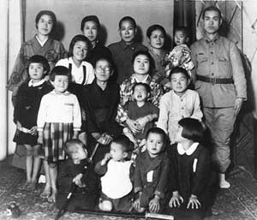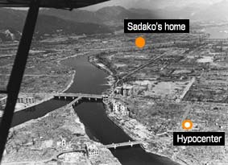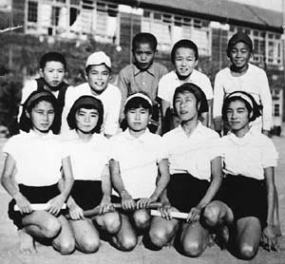
(Hiroshima Peace Memorial Museum, 2000)
(Hiroshima Peace Memorial Museum, 2000)
(Hiroshima Peace Memorial Museum, 2000)

Sadako’s classmates raised funds to create a memorial to her and to all the other children who died as a result of bombing attacks. On the morning of September 11, 2001, Al Qaeda terrorists hijacked airplanes and flew them into both buildings of the World Trade Center in New York City. The impact and damage caused both towers (110 stories each) to collapse. 2,973 people lost their lives as part of the terrorist attacks including the following public service employees who worked the scene: 343 FDNY firefighters, 23 NYPD police officers, and 37 Port Authority police (Funahashi & Brown, 2011, p. 6).

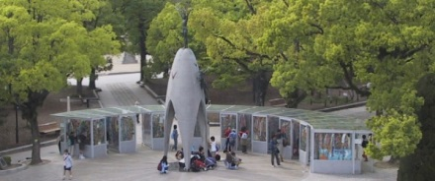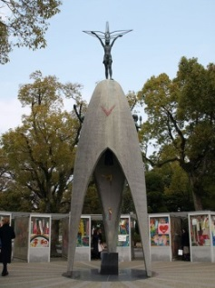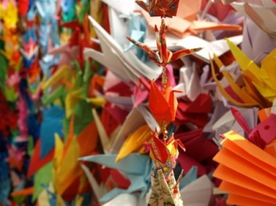
(Atendido, 2013)
(Hiroshima Peace Memorial Museum, 2000)
(The City of Hiroshima, 2001)
The World Trade Center: Twenty-six Japanese citizens died in the September 11th terrorist attacks on the World Trade Center. Families and friends of the lost Fuji Bank employees folded 10,000 paper cranes and sent them to the Tribute WTC Visitor Center (Funahashi & Brown, 2011, p. 7).

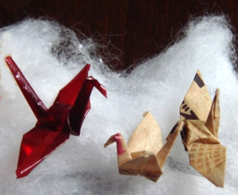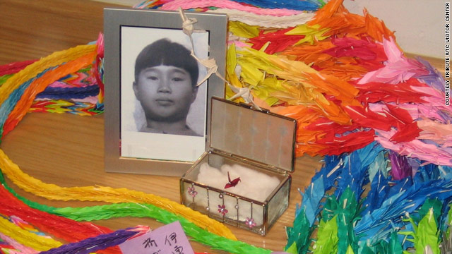
(Minamoto, 2010)
(Drash, 2009)

Sadako and the Tribute WTC Visitor Center: In 2007, Sadako’s older brother, Masahiro Sasaki, gave five of Sadako’s paper cranes to places around the world. One of Sadako’s small, red origami cranes was given to the Tribute WTC Visitor Center to be displayed with the chains of 10,000 origami cranes (Funahashi & Brown, 2011, p. 7).

Anticipation Guide
Sadako's Paper Cranes and Lessons of Peace

Directions: Read each of the following statements and in the “Before Reading” column, place a plus (+) if you agree with the statement and a minus (-) if you disagree. After reading Sadako's Paper Cranes and Lessons of Peace, you will complete the “After Reading” column to see if any of your initial responses have changed.

Before Reading | Statement | After Reading
 | The Manhattan Project was a beautification project in New York City, New York.
 | The Manhattan Project was a top secret project between President Franklin Delano Roosevelt and his top advisors.
 | The Manhattan Project was encouraged by scientists in efforts to create the first atomic bomb during World War II.
 | On August 6, 1945, the United States dropped an atomic bomb on the city of Hiroshima, Japan, but it was a bust and nearly caused us to lose war.
 | The United States actually dropped two bombs three days apart. One was in Hiroshima, and one was in Nagasaki.
 | It is impossible for people to survive an atomic bomb.
 | People can survive atomic bombs, but suffer from the effects of radiation afterwards.
 | Sadako Sasaki was two year old child who survived an atomic bomb.
 | Sadako Sasaki developed leukemia as a result of exposure to radiation from an atomic bomb.
 | The origami crane is a symbol of death.
 | According to Japanese tradition, anyone with the patience and commitment to fold 1,000 paper cranes will be granted their most desired wish.
 | Sadako folded 1,000 cranes, but died anyway.
 | Because Sadako’s family was poor, they could not afford a memorial, and she was forgotten by everyone.
 | Sadako’s origami cranes were burned because they did not save her.
 | The statue of a young girl holding a crane is a symbol for world peace.

