LESSON PLAN FORMAT

School Site: Middle School Content/Endorsement Area: Special Education/English Grade Level: 6 – 8 Daily Topic: Vocabulary

Unit Topic: Multicultural Literature: An Exploration of Diversity Amongst Cultural Groups

Lesson # _ 4__ (4 of 5)

- Pre-Planning: Academic Foundations/Standards or Benchmarks:
  - Virginia Standards of Learning Objectives
    - Vocabulary
      - 6.4, 7.4 The student will read and learn the meanings of unfamiliar words and phrases within authentic texts.
        - Use context and sentence structure to determine meanings and differentiate among multiple meanings of words.
        - Use word-reference materials.
        - Extend general and specialized vocabulary through speaking, listening, reading, and writing.
      - 8.4 The student will apply knowledge of word origins, analogies, and figurative language to extend vocabulary development within authentic texts.
        - Use context, structure, and connotations to determine meaning and differentiate among multiple meanings of words and phrases.
        - Use dictionaries, thesauruses, and glossaries to determine definition, pronunciation, etymology, spelling, and usage of words.
        - Discriminate between connotative and denotative meanings and interpret the connotation.
        - Extend general and specialized vocabulary through speaking, listening, reading, and writing.
- Instructional Setting: This lesson was developed for a self-contained class containing sixteen students in the special education program. The classes are 45 minutes long. The students’ desks are arranged in a manner to allow clear vision of the board and the screen for when using the LCD projector and document camera. There are three long cafeteria tables along the back of the room students can use for projects and activities requiring small groups as well as more space. There are seven Ipads and one desktop computer available for student use.

- Goal of the Lesson: The goal of this lesson is for students to be exposed and interact with unfamiliar words (Vacca, Vacca, & Mraz, 2014, p. 238). The teacher and students will experience the vocabulary lesson together to allow students an opportunity to learn how to use the strategies, and then students will independently complete the strategies using words from their independent novel study.

- Behavioral Objectives:
- The Behavior Verb: Each student will participate in the vocabulary strategies.
  - P.I.: TBD
- The Condition: While working collaboratively with others, students will complete the vocabulary activities.
  - P.I.: TBD.
- The Criteria: Upon analyzing the background information and the story, each student will complete the vocabulary activities.
  - P. I.: TBD

- Integration of other subject areas: This lesson plan parallels the social science content area through its lessons about the history of the atomic bomb, the relationship between the bombing of Hiroshima and a young Japanese girl, and the significance of an ancient Japanese legend and its impact all over world including the Tribute to the World Trade Center Visitor’s Center.

- Differentiation Strategies:
  - Culturally Responsive: Spanish cognates of pertinent vocabulary words will be available to the English Language Learner (ELL). Also, the English language learner will be provided with one-on-one assistance as needed to clarify, understand, and complete the activity.
  - Students will be able to use Ipads in pairs or small groups to read the free PDF version of the Japanese story cards.
  - Students will work in cooperative learning groups to complete the vocabulary activities.

- Safety considerations:
  - Safety considerations include appropriate use of the technology equipment during the assignment, and safe use of glue during the assignment.

- Resources, Equipment and Materials:
  - Copies of the attached background information which was teacher generated using Microsoft Word, but based on the original work written by Naomi Funahashi and Waka Takahashi Brown in collaboration with the Stanford Program on International and Cross-Cultural Education (SPICE) made possible by a grant from the United States-Japan Foundation.
  - Copies of the vocabulary word structure map

  - Copies of the vocabulary triangle
  - Copies of pre-cut subordinate vocabulary words ready to be glued onto graphic organizer under superordinate and coordinate vocabulary terms
  - Copies of the vocabulary concept map with the superordinate and coordinate vocabulary terms in place
  - Technology:
    - Ipad – Learn That Word Website
    - Ipad-Download Free PDF file:
Funahashi, N. (2011). Sadako’s paper cranes and lessons of peace. Retrieved from http://spice.stanford.edu/catalog/kamishibai_project/.

- Prerequisites: Students will have completed all of the reading activities from the previous lessons. Students will have prior experience using the following: Ipad, graphic organizers, Learn That Word website, scissors, glue

- Implementation: (Includes time estimates for each section)

- Motivator: (Day 1)
  - Before Reading Activity – Word Structure Matrix
    - (10 minutes) Students will work in small groups to complete word structure maps for the following vocabulary words which were found in the reading activities, but not used for the concept map: encouraged, pervasiveness, campaign. Students will learn word meaning by breaking down the structure of each work to review the prefixes, suffixes, definitions, and word origins (Vacca, Vacca, & Mraz, 2014, pp. 274-275).

- Procedures: Students will complete the activities in the following order.
  - During Reading Activity: 20 minutes
    - Students will complete the concept vocabulary map in small groups.
      - Students will review the superordinate and coordinate vocabulary terms provided in the designated areas on the concept map (Vacca, Vacca, & Mraz, 2014, p. 246).
      - Students will arrange the subordinate words and glue in place after having it checked by the teacher.
  - After Reading Activity: 10 minutes
    - Students will complete the vocabulary triangle in their small groups using the three vocabulary words defined at the beginning of the period. The words will be placed in each corner of the triangle, and students will be asked to write sentences connecting the words (Vacca, Vacca, & Mraz, 2014, p. 266).
- Closure (5 minutes): Students and teacher will discuss the interrationships between key vocabulary words

References
Atendido, R. (2013). The Hiroshima Peace Memorial [Photograph]. Retrieved from http://www.origami-resource-center.com/sadako.html
Coerr, E. (1997). Sadako and the thousand paper cranes. New York, NY: Puffin Books.
Drash, W. (2009, December 17). Sadako Sasaki, a survivor of the Hiroshima atomic bombing, made this red origami crane while dying of leukemia [Photograph]. Retrieved from http://www.cnn.com/2009/LIVING/12/17/origami.gift/index.html?_s=PM:LIVING
Funahashi, N. & Brown, W. T. (2011). Sadako’s paper cranes and lessons of peace: Teacher’s guide. Retrieved from http://iis-db.stanford.edu/pubs/22665/Sadako_Teacher's_Guide.pdf
Funahashi, N. (2011). Sadako’s paper cranes and lessons of peace [PDF Version]. Retrieved from http://spice.stanford.edu/catalog/kamishibai_project/.
Hiroshima Peace Memorial Museum. (2000). A young girl's death from the A-bomb--Sadako Sasaki, 12 years of age: Sadako's 4,675 days of life. Retrieved from http://www.pcf.city.hiroshima.jp/virtual/VirtualMuseum_e/exhibit_e/exh0107_e/exh01071_e.html
Hiroshima Peace Memorial Museum. (2000). Fastest Runner in the School [Photograph]. Retrieved from http://www.pcf.city.hiroshima.jp/virtual/VirtualMuseum_e/exhibit_e/exh0107_e/exh01071_e.html
Hiroshima Peace Memorial Museum. (2000). Sadako's parents hoped she would grow up healthy [Photograph]. Retrieved from http://www.pcf.city.hiroshima.jp/virtual/VirtualMuseum_e/exhibit_e/exh0107_e/exh01071_e.html
Hiroshima Peace Memorial Museum. (2000). The dropping of the atomic bomb [Photograph]. Retrieved from http://www.pcf.city.hiroshima.jp/virtual/VirtualMuseum_e/exhibit_e/exh0107_e/exh01071_e.html
Hiroshima Peace Memorial Museum. (2000). Two months after the atomic bombing [Photograph]. Retrieved from http://www.pcf.city.hiroshima.jp/virtual/VirtualMuseum_e/exhibit_e/exh0107_e/exh01071_e.html
Minamoto, K. (2010, August 4). Three of Sadako's original cranes, one of which can be viewed at the Tribute WTC Visitor [Photograph]. Retrieved from http://japansocietyny.blogspot.com/2010/08/sadako-1000-cranes.html.
Origami Resource Center. (2013). The Story of Sadako. Retrieved from http://www.origami-resource-center.com/sadako.html
Stanford University. (n. d.). Spice Publications. Retrieved from http://spice.stanford.edu/catalog/kamishibai_project/
The City of Hiroshima. (2001). The children's peace monument [Photograph]. Retrieved from http://www.city.hiroshima.lg.jp/shimin/heiwa/monument.html
UShistory.org (2008). 51f: The Manhattan Project. Retrieved from http://www.ushistory.org/us/51f.asp
Vacca, R. T., Vacca, J. L., & Mraz, M. (2014). Content area reading: Literacy and learning across the curriculum. Boston, MA: Pearson.
Virginia Department of Education. (2010). English Standards of Learning for Virginia Public Schools. Retrieved from http://www.doe.virginia.gov/testing/sol/standards_docs/english/2010/stds_english8.pdf

Background Information: Sadako's Paper Cranes and Lessons of Peace

Introduction: In 2007, a Japanese man by the name of Masahiro Sasaki presented a gift of an origami paper crane to the Tribute World Trade Center Visitor Center in New York City (Funahashi & Brown, 2011, p. 5).

History: The Manhattan Project began in 1941, during World War II. President Franklin Delano Roosevelt was encouraged by scientists to start the Manhattan Project in efforts to create the first atomic bomb before Nazi Germany did. The Manhattan Project, which cost nearly $2 billion, was kept as a secret between the President and his top advisors (Funahashi & Brown, 2011, p. 5).

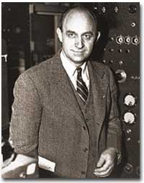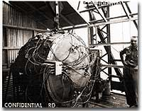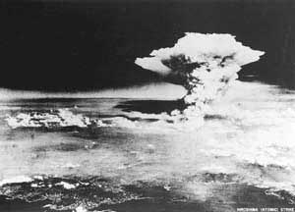
(UShistory.org, 2008)
2008)
(Hiroshima Peace Memorial Museum, 2000)
(UShistory.org, 2008)

In the beginning, the atomic bomb was intended for Germany, but by mid-1944 President Roosevelt and his advisors changed the target to Japan. They hoped the bomb would lead to Japan’s surrender and end the war (Funahashi & Brown, 2011, p. 5).

On August 6, 1945, the United States military dropped an atomic bomb on the city of Hiroshima, Japan. The uranium-based bomb exploded with a force equal to 13,000 tons of TNT. On August 9, three days later, the military dropped a second atomic bomb on Nagasaki, Japan. The plutonium fueled bomb exploded with a force equal to 20,000 tons of TNT. The explosions of these bombs caused intense heat, shock waves, blast winds, and deadly radiation. Approximately 140,000 people in Hiroshima and 70,000 people in Nagasaki died as a result of the bombing (Funahashi & Brown, 2011, p. 5)..

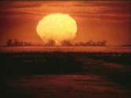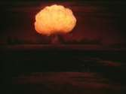
(UShistory.org, 2008)

(UShistory.org, 2008)

(UShistory.org, 2008)

Japan’s Surrender: Japan offered a conditional surrender, and President Harry S. Truman told his cabinet that he did not want to kill any more women and children even though there were plans to drop more atomic bombs on Japan (Funahashi & Brown, 2011, p. 5).

Radiation Effects: Most of deaths from the bombings took place from the time of the drop to the end of 1945; however, bomb survivors continued to die from bomb-related injuries or illnesses for many years. People did not know very much about radiation and its effects on humans when the bombs were dropped. There were many people who survived the explosions, but they were also exposed to significant amounts of intense radiation. A sudden increase in juvenile leukemia occurred in both Hiroshima and Nagasaki after the bombings (Funahashi & Brown, 2011, p. 6).

Sadako Sasaki: Sadako Sasaki was two years old at the time the atomic bomb was dropped on Hiroshima. At the age of twelve, Sadako developed leukemia as a result of her exposure to the radiation from the bomb. During her hospital stay, Sadako’s father told her about a legend that stated her wish for good health could come true if she could fold one thousand paper cranes. She began folding the paper cranes using whatever paper was available including wrapping paper from get-well gifts and medicine-bottle wrappers. Although Sadako folded more than a thousand origami cranes, she succumbed to her illness on October 25, 1955 (Funahashi & Brown, 2011, p. 6).
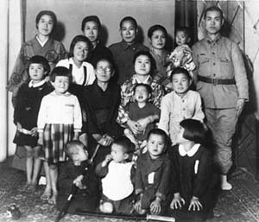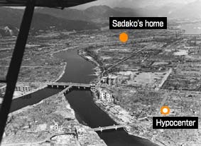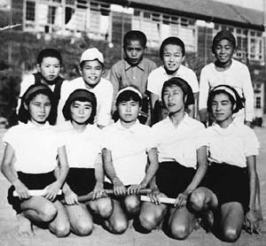
(Hiroshima Peace Memorial Museum, 2000)
(Hiroshima Peace Memorial Museum, 2000)
(Hiroshima Peace Memorial Museum, 2000)

Sadako’s classmates raised funds to create a memorial to her and to all the other children who died as a result of bombing attacks. On the morning of September 11, 2001, Al Qaeda terrorists hijacked airplanes and flew them into both buildings of the World Trade Center in New York City. The impact and damaged caused both towers (110 stories each) to collapse. 2,973 people lost their lives as part of the terrorist attacks including the following public service employees who worked the scene: 343 FDNY firefighters, 23 NYPD police officers, and 37 Port Authority police (Funahashi & Brown, 2011, p. 6).

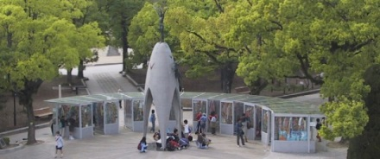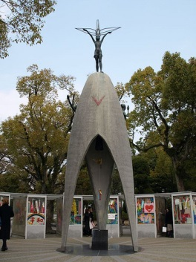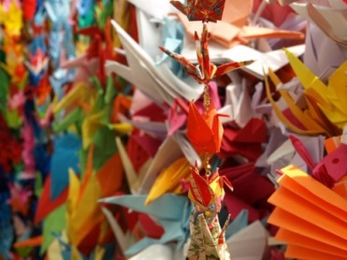
(Atendido, 2013)
(Hiroshima Peace Memorial Museum, 2000)
(The City of Hiroshima, 2001)
The World Trade Center: Twenty-six Japanese citizens died in the September 11th terrorist attacks on the World Trade Center. Families and friends of the lost Fuji Bank employees folded 10,000 paper cranes and sent them to the Tribute WTC Visitor Center (Funahashi & Brown, 2011, p. 7).

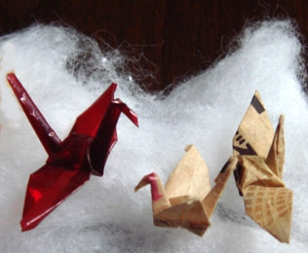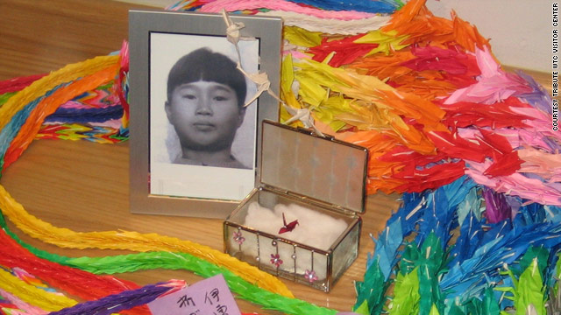
(Minamoto, 2010)
(Drash, 2009)

Sadako’s and the Tribute WTC Visitor Center: In 2007, Sadako’s older brother, Masahiro Sasaki, gave five of Sadako’s paper cranes to places around the world. One of Sadako’s small, red origami cranes was given to the Tribute WTC Visitor Center to be displayed with the chains of 10,000 origami cranes (Funahashi & Brown, 2011, p. 7).

Word Structure Matrix
Vocabulary Word | Prefix | Suffix | Word Origin | Definition | Sentence
Encouraged

Campaign

Pervasiveness

Warfare
illness
disease
Juvenile Leukemia
succumbed to cancer
Common Nouns
hope
peace
compassion
origami cranes
Children’s Peace Monument
memorial
advisors
survivors
terrorists
citizens
family
students
President Roosevelt
Masahiro Sasaki
Sadako
President Harry S. Truman
Sadako’s Impact on the World
conditional surrender
intense heat
blast winds
shock waves
explosions
deadly radiation
uranium-based bomb
atomic bomb
plutonium fueled bomb
United States
New York City
World Trade Center
Tribute WTC
Visitor Center
Asia
Effects of Bombings
Japan

Hiroshima
Atomic Bomb Survivors Hospital
Hiroshima Peace Memorial Park
Nagasaki
Nagoya
Manhattan Project
North America
Bombings
Proper Nouns AmericaP
Effects of Radiation
Locations
Sadako
People
Sadako’s Paper Cranes
and Lessons of Peace

